Title
The Islamicity of Lanao Sultanate, Philippines in the 17th Century as a State
By Sohayle M. Hadji Abdul Racman
Abstract
The Pat a Pangampong sa Ranao or Lanao Sultanate in the Philippines was founded in the early 17th century after its leaders seceded from the Magindanao Sultanate. The Lanao Sultanate had the traditional laws i.e. the taritib and igma or the Adat Laws, and Shari’ah (Islamic laws). The political structure of Lanao Sultanate consists of council of elders, house of board of advisers, house of bais (ladies), imāms (prayer leaders), kalis (judges), gurus (teachers), askars (army), pananalsilas (genealogy experts), defence units headed by a radia-laut (naval and war commander), and the forty-three clans who ruled the pagawidan (supported) states and pagawid (supporting) states. The supported states had fifteen sultans who were the executive bodies of the fifteen royal houses of the Lanao Sultanate. The pagawid (supporting) states had twenty-eight governors called m’babaya ko taritib who were also the legislative bodies of the four states of Lanao: Bayabao, Masiu, Unayan, and Baloi. The Islamicity of the Lanao Sultanate in the 17th century as an Islamic state is not represented in literature. This explains why there is a huge research gap on this study. This paper will explore in-dept the Islamicity of Lanao Sultanate as a state in the 17th century using Islamic state as a model according to Muslim scholars.
Key words: Islamicity, Lanao Sultanate

Introduction
The Pat a Pangampong sa Ranao or Lanao Sultanate in the Philippines was founded by the Maranao datus in the early 17th century. The Maranao datus decided to secede from the Magindanao Sultanate during the reign of Sultan Kudarat. According to Sultan Monsing Macabando, the Maranao datus of Lanao who founded the Lanao Sultanate were inspired by Qur’ānic teaching on establishing Islamic leadership. Sultan Monsing Macabando says, “Hay so miyamaratiyaya na onotiniyo so Allāh, onotiniyo so Rasulollah (s.aw.) nago so mga datu iyo. Okaka samok kano nandud kano ko kitabo o Allāh nago so sabdan o Nabi Mouhammad (s.a.w.).” Meaning, “O you who believe! Obey Allāh, and obey the Messenger (Muhammad), and those of you (Muslims) who are in authority. (And) If you differ in anything amongst yourselves, refer it to Allāh and His Messenger, if you believe in Allāh and in the Last Day. That is better and most suitable for final determination.” It is clear that Sultan Monsing Macabando quotes from the Qur’ānic verse i.e. Sūrah An-Nisā, 4:59. This means that Lanao datus who founded the Lanao Sultanate were aware of the above Qur’ānic verse and its meaning which guided them in establishing the Lanao Sultanate; and to obey God, His messenger, Prophet Muhammad (pbuh), and the people in authority i.e. the leaders.

Statement of the Problem
1. What are features of an Islamic state?
2. Are these features corresponds to the Lanao Sultanate in the 17th century as a state?

Objectives of the Study
1. To highlight the features of an Islamic state.
2. To know whether the Lanao Sultanate in the 17th century as an Islamic state or not.
Significance of the Study
This study is significant in filling the research gap in literature on the foundation of the Lanao Sultanate in Mindanao, Philippines in the 17th century with specific emphasis on Islamic governance. It broadens the historical narratives on dominant socio-political forces which took place in the Philippines which lead to the inception of Lanao Sultanate. It will contribute to theory building on the evolution of the Maranaos datu-ship system into Islamic governance which survives to date. This serves as a reference material for the researchers. It will promote open and constructive debates on how applied Islamic governance helped developed the civil and religious life of the natives in the Philippines in the 17th century. It will provide inputs for the state policy makers in promoting of better Islamic governance in the Muslim regions in the Philippines. This study also contributes to the body of knowledge on Islamic civilization in Southeast Asia as well as on the significance of the Lanao Sultanate in the way of life of the Maranao communities.
Research Methodology: Qualitative Research
The historical narratives for this research can be obtained through library research, government documents and archives. Secondary data sources i.e. books, theses, dissertation, and journals were used.
Expected Results of the Study
Hopefully, the results of this study will (1) show and broaden the historical narratives on the dominant socio-political forces in the Philippines pertaining to the inception of the Lanao Sultanate in Mindanao. (2) Show how applied Islamic governance shaped the civil and religious lifeways of the Maranao natives in the Philippines in the 17th century. (3) Provide original inputs for the state policy makers for the promotion of better Islamic governance in the Muslim dominated areas in Mindanao, Philippines. (4) See from this research findings of its relevance to the existing sultanates in Lanao, thus the incumbent sultans may reflect on the thesis findings as to enhance their leadership and by so doing to affect socio-cultural, political and religious consciousness and construct of the Ummah (Muslim community) This might lead to the cooperation between the sultans and the local government units in Lanao areas.
The Foundation of Lanao Sultanate
According to Sultan Monsing Macabando, the Lanao Sultanate in Lanao was founded when it separated from the Magindanao Sultanate during the preparation of the enthronement rites of Sultan Kudarat as sultan of Magindanao. Sultan Monsing does not provide the date of the enthronement rites of Sultan Kudarat. However, according to Ruurdje Laarhoven, Sultan Kudarat began his reign as Sultan of Magindanao in 1616, this date was based from Dutch source. Basing from the Dutch source as stated above, it is therefore, that the Lanao Sultanate was founded in 1616, respectively.
In this light, let us discuss the foundation of the Lanao Sultanate. Sultan Monsing Macabando explains that when the people of Magindanao and Lanao had accepted Islam as their religion, Sharīf Kabunsuan, an Arab-Malay, introduced the sultanate leadership to his in-laws in Lanao and Magindanao, Mindanao. During this time the Lanao and Magindanao were still united as a single state. When Sharīf Kabunsuan was very old, he relinquished his title as sultan of Magindanao to his son, Sharīf Makaalang who became the first native Maranao sultan of Magindanao. He was the son of Sharīf Kabunsuan from his Maranao wife, Bae Angintabo from Malabang, Lanao. Sharīf Makaalang was succeeded by his son Sharīf Bangkaya who was later succeeded by his three sons: Dimasangkay Adil, the eldest. He was then succeeded by Gugu Sarikula who was then succeeded by his youngest brother Sultan Laut Buisan.
When Sultan Laut Buisan passed away, his son Sultan Kudarat wanted to be crowned as sultan of Magindanao. However, during that time, the leadership of Magindanao Sultanate should be rotated to Lanao by enthroning the Maranao son of Dimasangkay Adil in Lanao. Sultan Kudarat, who was in Magindanao, summoned his relatives in Lanao to come to his place in Noling, Magindanao. The datus who came to Noling were Dianatun Naim of Butig, Diwan of Bayang, Balindong B’sar of Masiu, Ottowa and Simbaan Akari of Ramain, Okoda of Lumba-Bayabao, Umbaor of Bansayan, Ibango of Maribo, Digoa of Bacolod, Atoki of Borokot, Aloyodan of Minitepad, Aribo of Rogan, Datu Bimban of Taporog, Palawan of Bansayan, Olok of Ditsaan, Arobero of Pagayawan, and other datus from Baloi and Macadar. This means that there was once a centralized leadership in Lanao and Magindanao and the leadership was by rotation technique, i.e. after the leadership of people from Lanao, then the leadership will be rotated to the people of Magindanao and vice-versa. Any centralized head of state would rule both Lanao and Magindanao at the same time.
Sultan Monsing Macabando narrates that,

When the datus of Lanao arrived in Noling, they were surprised by the kalilang (musical festivities using kolintang orchestra) being held. Dipatuan Kudarat told the datus of Magindanao and Lanao, saying: “I have a girlfriend whom I wanted to marry, allow me to propose to all of you, who among you would like to marry her, in case I do not want marry her?” One of the datus replied and said, “Let us allow Balindong B’sar to response to your proposal.” Then Balindong B’sar said, “Yes, I will marry her if you do not want to marry her so that we would become a couple”. Dipatuan Kudarat smiled and said, “My dear fellow how could you take my lady from me; may I ask all of you to stay here for few days while our festivities were going on. In few days from now, I will be enthroned as Sultan of Magindanao.” Dianaton Naim was dismayed when he heard that Dipatuan Kudarat announced to the crowd that he wanted to become the Sultan of Magindanao. Dianaton Naim told Sultan Kudarat, “Oh, are you deceiving us? Indeed you deceived us, if your plan is to become the Sultan of Magindanao then, starting from today the Lanao and the Magindanao should be separated, you will rule Magindanao and we will rule Lanao, so, we are going to leave you now”.

Sultan Monsing Macabando states that after they left the crowd, they went to Sugod in Parang in Magindanao to get their horses. When they arrived in Sugod, they hopped on their horses and started their travel way back to Butig, Lanao. At their arrival in Butig, they took a rest for a while and then started discussing on establishing a Sultanate in Lanao. Upon the consensus of all datus, they had chosen Balindong B’sar to be the Sultan of Magindanao in Lanao whose title is Sultan a Diagaborola, which means someone who does not sleep for the sake of enforcing the teachings of Islam. Balindong B’sar said to the crowd of datus, “that is a brilliant idea and I would like to express my gratitude to all of you for that but I do not want to be enthroned here in Butig, Lanao. I wish to be enthroned in my birthplace, Taraka, so, we are going back home, after a month let us meet again in Taraka”.
Sultan Monsing Macabando narrates that a month later, the datus of Lanao were assembled in Taraka, the datus from Masiu were all present in the assembly, they were exhausted so they took a rest for a while, then they ate and began discussing. Balindong B’sar said to the datus, “We unanimously agreed that we will not have a single Sultanate like that of Magindanao, what we want is to make the four states of Lanao as co-equal in power and authority by creating them into a confederation of sultanates wherein each district of the principalities of Lanao shall enthrone their own sultan respectively… after a month let us all meet in Sawir, Lanao so we shall be closing this meeting”.
Sultan Monsing Macabando states that a month later, the Lanao datus were assembled in Sawir, Lanao; they followed the agreement which they all agreed in their previous meeting that each suku (district) of the pangampong (state) shall establish a sultanate. The Pangampong of Unayan which was one of the states of Lanao was divided into the East Unayan and the West Unayan. The clan of Dozonan and Matanog took the leadership over the Pangampong of Unayan. The son of Matanaog was enthroned as the sultan of East Unayan, while Dozonan was enthroned as sultan of West Unayan. The Pangampong of Bayabao and Masiu also enthroned their respective sultans. Sultan Monsing Macabando narrates that the datus of Lanao were assembled again in Taraka, the birthplace of Balindong B’sar. They also drafted the taritib and igma of Lanao, after the Lanao datus had all unanimously agreed, they made a pact and pledged to the Qur’ān that each of them shall abide and follow their agreement religiously. They spoke a ritual and uttered, “tinimbakan, linilayan sagui, biomboran sa ombi, pisa-an sa oraka manok, biotosan sa alad. Giyoto i khasowa o minasaon a misogaton pun a giangkaia pat a a mala a paninta sa Ranao, inontabo pagayon nayon siran taman ko pkababadan kiran.” Tinimbakan (they had gun fire); linilayan sagui (they hung hay leaves); biyomboran sa ombi (they sprinkled ash); pisaan sa orak a manok (they broke chicken eggs); biyotosan sa alad (they ripped out a fence); “whoever disagree with the taritib and igma will meet these spoken curses and shall face the four curses of Lanao, except if and when they agree among themselves and their descendants to amend the taritib and igma. The four curses in Lanao were Kabugawan o Bugao sa Unayan, Kasongkoran o Songkor sa Masiu, Kagapunan o Gapun sa Bayabao, and Kana-asan o Naas sa Baloi. These four curses refer to the severe sickness or incurable diseases that will be suffered by people who will misuse the taritib and igma of Lanao. The closing ceremony of the said ritual signifies the historic reconfiguration of the leadership in Lanao and Magindanao. This was also the beginning of the separation of leadership of Lanao from Magindanao.
Sultan Monsing Macabando states that the taritib and igma of Lanao shall be the bases in governing their states’ leadership and that their taritib and igma shall not be distorted and misused. That time, they founded the fifteen pagawidan or superordinate sultanates and the twenty-eight pagawid or subordinate sultanates, they also revived the four states dividing the Four States of Lanao and also the state’s barangay (smaller community) divisions. They also categorized and determined the other administrative division of the four states of Lanao such as the ‘ulamā’, imāms, gurus, bais (queens or sultana) and others.
Sultan Monsing Macabando states that there was no written agreement between the Lanao and Magindanao Sultanates on the separation of the Four States of Lanao from the Magindanao Sultanate due to the fact that both sultanates’ descent lines sprang from Sharīf Kabunsuan. According to Shinzo Hayase, Sharīf Kabunsuan was an Arab-Malay, and Bae Angintabo was a Maranao from Malabang, Lanao. Sharīf Makaalang, an Arab-Malay-Maranao by birth, a son of Sharīf Kabunsuan and Bae Angintabo. Shinzo Hayase states that Sharīf Makaalang reigned as a sultan of Magindanao in 1536 to 1556; he was succeeded by his son Sharīf Bangkaya who reigned in 1556 to 1578; then he was succeeded by his son Dimasangkay Adil who reigned in 1578-1596. According to Cesar Adib Majul, Dimasangkay Adil was succeeded by Gugu Sarikula who was succeeded by Kapitan Laut Buisan, who was the youngest brother of both Dimasangkay Adil and [Gugu] Sarikula. Kapitan Laut Buisan reigned in 1597 to 1619; then he was succeeded by Sultan Kudarat, a son of Kapitan Laut Buisan, he reigned in 1619 to 1671.
It is interesting to note that the Lanao Sultanate did not separate its naval and military power from the Magindanao Sultanate. According to Sultan Monsing Macabando the Lanao Sultanate provided Iranon people (Maranaos living in the seacoasts of Mindanao) and Maranao men from the Four States of Lanao to the Magindanao Sultanate to form a naval and military forces in their fleet. He states, “Giyoto i kiyatharo aon a so Magindanao Sultanate na pindatuan o mga Maranao,” (That is the reason why it was said that the Magindanao Sultanate was governed by the Maranao people), “ago ditano kasapngan so history tano” (and most importantly we can never change our history). It is also correct to say that the Magindanao Sultanate was governed by the Maranao people since the time of Sharīf Makaalang and even until now.” This claim is acceptable due to the fact that the 1st Maranao-Arab-Malay sultan of Magindanao was Sharīf Makaalang, he was succeeded by his son, Sharīf Bangkaya, who was succeeded by Dimasangkay Adil, who was succeeded by Gugu Sarikula who was succeeded by Kapitan Laut Buisan, who was then succeeded by Sultan Kudarat. Dimasangkay Adil, Gugu Sarikula, and Kapitan Laut Buisan were sons of Sharīf Bangkaya from his three wives. All these sultans were all descendants of Bae Angintabo, a Maranao lady from Malabang, Lanao, who was the wife of Sharīf Kabunsuan, the first Arab-Malay sultan of Magindanao.
The Lanao Sultanate is located in Lanao del Sur today. There are four provinces that surround Lanao del Sur, namely, (1) Lanao del Norte in the northwest, (2) Bukidnon in the east, (3) Magindanao, and (4) Cotabato in the south. Lanao del Sur is bordered by Illana Bay to the southwest. It is teemed with hills and volcanoes, and endowed with green forests, wild life, flora and fauna. Majority of its land area is covered in thick forests. Its area is further divided into production forest and agricultural land (2,540.7 km2), and alienable and disposable land, which include land area for production, protected areas, and land areas for development.
The map of the Philippines below shows the location of Lanao Sultanate in the Southern part of Philippines in Mindanao Island.
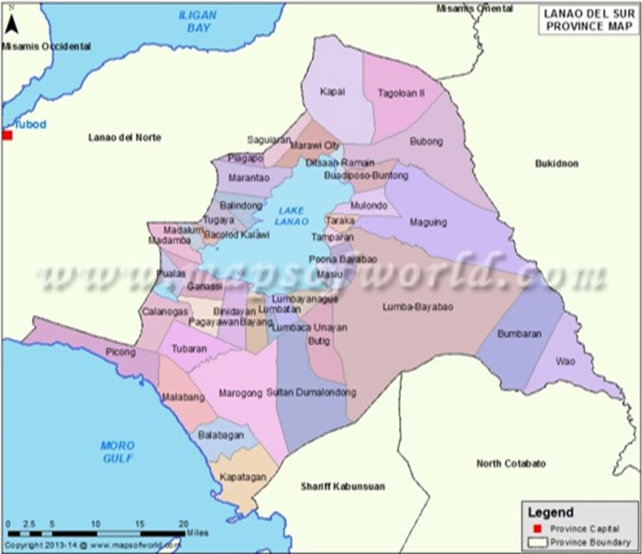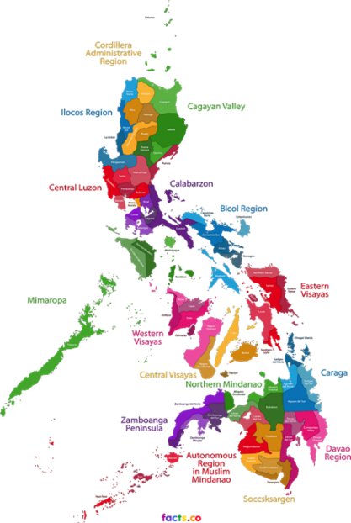

Characteristics of Lanao Sultanate
Sultan Monsing Macabando states that the Sultanate of Lanao is a “collective leadership in order to promote unity and strong brotherhood and the equality of the Maranaos. It is also a consultative Monarchy… which is equivalent to Monarchical Democracy…” The Lanao Sultanate was divided into division and each division was then divided into sub-division. There were fifteen sultanates which were ruled by fifteen panoroganans. Panoroganans were sultans from the fifteen pagawidan (supported) states. The division and sub-division of the Lanao Sultanate were ruled by the twenty-eight sultans from the twenty-eight pagawid (supporting) states. The sultans from pagawidan and pagawid states were inter-dependent on one another based on their taritib and igma.
Sultan Monsing Macabando states that the Lanao Sultanate was being ruled by the fifteen pagawidan (supported) sultans of the fifteen Royal Houses. These sultans assume the authority, powers, control and supervision over their respective pangampong (sultanate). The fifteen supported sultans of the fifteen Royal Houses were being assisted by the twenty-eight Houses of Peers or Policy Makers from the twenty-eight pagawid (supporting) states. The main function of the Houses of Peers is “to legislate local customs, traditions and laws but subject to the joint concurrence of the Royal Houses, Council of Elders and the Board of Advisers.” Sultan Monsing Macabando explains that the Council of Elders and the Boards of Advisers are both advisers to the Royal Houses and House of Peers. The decision-making process in the Lanao Sultanate is not a monopoly of the sultans but it is based on the consensus of the Council of Elders and the Boards of Advisers and other traditional leaders.
The chart below shows the Confederate States of the Lanao Sultanate. There are four major states of the Lanao Sultanate i.e. Unayan, Masiu, Bayabao and Baloi. The ruling clans of each state traced their line of ancestry from Sharīf Kabunsuan. The State of Bayabao has three sukus (districts) namely, Poona-Bayabao, Lumba-Bayabao, and Mala-Bayabao. The three districts of the state of Bayabao has nine panoroganan/superordinate sultanates (executive bodies) and twelve subordinate sultanates (legislative bodies). The Pangampong of Bayabao was the largest pangampong (state) in terms of number of its executive and legislative bodies combined. The State of Masiu was divided into the East and West Masiu. The State of Masiu has only two panoroganan/superordinate sultanates (executive bodies) and four subordinate sultanates or legislative bodies. It was the 3rd largest state in terms of number of its executive and legislative bodies combined. The State of Unayan has two districts namely Butig and Domalondong. It has three panoroganan/superordinate sultanates (executive bodies) and eight subordinate sultanates (legislative bodies). It was the 2nd to the largest state in terms of number of its executive and legislative bodies combined. The State of Baloi has no district. It is at the same time a panoroganan/superordinate sultanate, and executive bodies as well. The State of Baloi has four subordinate sultanates (legislative bodies). It was the smallest state. Legislative bodies refers to the twenty-eight pagawid (supporting) states. Each of these states has m’babaya ko taritib or law-making bodies or houses of peers who were also governors of the twenty-eight supporting states.

1. PANGAMPONG/STATE OF BAYABAO
Suku/District | Founding  Ancestors | The 15 Superordinate Sultanates/Pagawidan/ Executive Bodies | Current Locations | The 28 Subordinate Sultanates /Pagawid/Legislative Bodies/M’babaya ko taritib/  Governors | Current Locations
a.Poona-Bayabao | a.Umbaor | 1.Bansayan of Umparo  2.Taporog of Amidbunol  3.Rogan of Aribo | Poona-Bayabao | 1. Talagian of Sheik  2. Bubong of Omilang  3. Bualan of Onawal  4. Lumbak-a-inged in Sisianun of Ayonga; siblings. | a.Poona-Bayabao
b.Lumba-Bayabao | a.Apha  b.Okoda  c.Ibango  d.Digoa | 4.Borocot of Apha  5.Minitupad of Okoda  6.Maribo of Ibango  7.Bacolod of Digoa | Lumba-Bayabao | 5. Galawan of Domaraag  6. Botod of Dikaizadan  7. Taluan of Alapang  8. Maguing of Mamintal; kins/SK. | a.Lumba-Bayabao,  b.Wao
c.Mala-Bayabao | a.Ottowa | 8.Ramain of Acari  9.Ditsaan of Olok | Ramain-Ditsaan | 9. Marawi of Gomisa  10. Marantao of Gomising  11.Buadipuso-Buntong of Macadiar  12. Antanga-Didagun of Mayaman; siblings. | a.Marawi City,  b.Marantao  c.Ramain-Ditsaan  d.Saguiaran
2. PANGAMPONG/STATE OF UNAYAN
a.Butig | a.Barakat | 10.Butig-East Unayan of Barakat | a.Butig | 13. Ragayan of Didaitun  14. Timbab of Subor  15. Malalis of Labiolan  16. Dolangan of Ditucalan; siblings | Butig
b.Domalon-dong | b. Borowa | 11.Pagayawan-West Unayan of Arobiro  12.Bayang-West Unayan of Diwan | a.Pagayawan, West Unayan,  b.Tatariken,  c.Bayang | 17. Binidayan of Baudi  18. Pualas of Lawango, sibling of Buadi.  19. Padas of Sandab II  20. Boribid of Matanog II, sibling of Sandab II. | a.Binidayan  b.Pualas  c.Tubaran  d.Tatariken
3. PANGAMPONG/STATE OF MASIU
a.East & West Masiu | a.Balindong B’sar | 13.Sultan sa Masiu of Racmatullah  14.Datu-a-Kabugatan sa Masiu of Dialaloden, brother of Racmatullah | Taraka | 21. Lumasa of Cadayon  22. Malungun of Madayao  23. Pitakes of Abagat, sibling of Madayao & Cadayon.  24. Lima-inged/five states: (a) Wato, (b) Tugaya, (c) Kalawi-Bacolod, (d) Madalum, and (e) Madamba of Pondag. | a. Bacolod  b.Taraka  c.Balindong  d.Madalum
4. PANGAMPONG/STATE OF BALOI
a. Baloi | a. Alanak | 15. Baloi of Alanak | Baloi | 25. Basagad of Papas Anas  26. Matampay of Radiali  27. Kabasagan of Atongao  28. Lumbak of Bae-sa-Lumbak | a.Baloi  b.Matunggao  c.Baloi  d.Baloi
The Pat a Pangampong sa Ranao’s Geo-Political Divisions

According to Sultan Monsing Macabando, the Lanao Sultanate has also the House of ‘ulamā’ (learned scholars). These scholars were the legal and religious advisers and judges of the Lanao Sultanate. The Lanao Sultanate has the House of the Four Landmark Sultanates, the House of the ladies (bai, bai-a-labi and potri-maamor). It also has gurus (teachers), imāms (religious ministers), and pananalsilas (genealogists) who kept the genealogy of the ruling clans. During the Spanish period, the Lanao Sultanate has askars or peace keeping force who maintain peace and order in Lanao; it has also military and naval force which then regularly joining the naval force of the Magindanao and Sulu Sultanate. These joint forces were intended for military expeditions against the Spanish forces and military bases in the Islands of Visayas and Luzon. The Spanish forces were composed of Spanish men and Christianized Filipinos from the Islands of Visayas and Luzon. The Spanish leaders used the Christianised Filipinos in their policy of wars against the Muslim people in Mindanao whom they called Moro.
The Christianized Filipinos were used by the Spanish to invade the territory of the Maranaos. According to Mamitua Saber, the Spaniards colonial forces pursued military, and spiritual campaigns towards the Maranao people in the shores of Lake Lanao. It was in April 4, 1639, when a Spanish conquistador Corcuera sent the first Spanish expedition to the Maranao inhabitants of Lake Lanao areas. This expedition was composed of Spaniards and hundreds of troops of Boholanos who were native people from the island of Bohol in Visayas, the central part of the Philippines. These campaigns were jointly commanded by Captain Francisco de Atienza and a Portuguese Recollect missionary, Fray Agustin de San Pedro. Atienza and San Pedro managed to entering alliance with some of the chiefs or datus of Lanao. In 1640, Corcuera sent Don Pedro Bermudes Castro to Lake Lanao. Don Pedro Bermudes Castro established garrison to establish the Spanish sovereignty in the areas of the Maranao people in Lanao. Later on, the Maranaos became suspicious and were alarmed by the threat of subjugation, hence, they drove back the Spaniards to the coastal town in Mindanao. They also burned the Spanish installations in Lake Lanao. After this incident, the Spanish forces never return to the Maranao areas in Lake Lanao for over 250 years. According to Mamitua Saber, “the Maranao people maintained their independent nation under the pangampong (state or sultanate) organization which was free from European domination.”
When the Americans came to the Philippines, they fought against the Spanish authorities in the Philippines for political control and power over the Philippines. According to Helen R. Tubangui, et al., the war between the United States and Spain ended under the Treaty of Paris which was signed in December 10, 1898. Spain ceded the Philippines to the United States which it paid $20,000,000 to Spain to compensate the cost of improvements that Spain spent to its colony, the Philippines. In the 19th century, the Maranaos were again struggling to resist another superior force, the Americans, and then later, the Japanese who came during the Word War II. If these superior forces did not come to Philippines, it is likely that the fate of the Maranaos would be still under the sultanate system of government today.
The Socio-Political and Religious Structure of the People of Lanao Sultanate
According to Mamitua Saber and Mauyag M. Tamano, “some tentative formulations might be stated about the narrow gaps between ranks and prestiges for their significance in behavioural relationships. Although an individual generally derives his prestige from his kin-group status, there is a categorical ladder of individual ranks.” These ranks can be observed within the Lanao Sultanate’s communities, as follows:
1. A pagawidan sultan: a highest rank, even higher than pagawid sultan.
2. A minor pagawidan: a titled man, a rank higher than a minor pagawid titled man.
3. A pagawidan non-titled man, a social rank higher than a pagawid non-titled man.
4. The rank of male enjoys is higher than that of the female.
5. The rank of adults is higher than children.
6. The rank of slaves is the lowest rank.

This categorical ladder of individual ranks in Maranao societies in Lanao Sultanate shows that there was a social hierarchy between individuals in terms of social status, age, gender, ancestral origin or descent lines, particularly in terms of whether a person is from the pagawidan and pagawid clans or not.
Nagasura T. Madale, points out that the pagawidan clans occupied fifteen pagawidan (supported) states, and the pagawid clans occupied twenty-eight pagawid (supporting) states. At that time, there were fifteen pagawidan clans, and twenty-eight pagawid ruling clans of Four States of Lanao or Lanao Sultanate. There was also lipongan, the lowest organizational stratum in the Four States of Lanao. Mamitua Saber and Mauyag M. Tamano state that, “with the Moriatao Balindong (descendants of Balindong) as the capital, the Taraka District territory (where the sultan of Masiu still maintains his influence even after the succession of communities in West Masiu)” has been divided into lipongan groups [of] villages.” The class of the members of lipongan was lower compared to that of the members of Moriatao Balindong. Individuals or groups who established a separate mosque gained an autonomous status. In the past, the lipongans in Taraka were called agamas. Mamitua Saber and Mauyag M. Tamano explain that in Taraka, each community rendered service to the ruling class in the following manners:
Lipongan A- which refused to be regarded as a lipongan due to a relatively better social status, “voluntarily” answered the utility needs of the two ruling classes. In times of war they gave military protections for the Sultanate. They were a warrior class.
Lipongan B- also of better status, kept the yellow and green royal flags of the sultan and his heir-apparent.
Lipongan C- of relatively lower status, was composed of fishermen and land tillers who gave tributes out of their produce to the rulers and their families. They also served as warriors.
Lipongan D- were carpenters and artisans charged with the construction and repair of the royal houses and the furnishing of a royal litter called osonan during enthronement, wedding, and funeral ceremonies.
Lipongan E- were “light-keepers” who illuminated the royal houses during social and ceremonial gatherings.
Lipongan F- maintained the environmental arrangement and sanitary conditions of the royal houses’ premises.
Lipongan G- were charged with the work of replacing the worn out or termite-eaten huge posts of the royal houses.
Lipongan H- kept the fishing equipments of the sultan and his heir-apparent.
Lipongan I- carried the osonan litter during royal funerals.

The sultanate of Taraka was the capital state of the Pangampong of Masiu, which was one of the four states of the Pat a Pangampong sa Ranao (the Four States of Lanao Sultanate). The different lipongans in Taraka assumed various functions and roles, respectively. These different functions of the state of Taraka were delegated to people based on their social status. We see different levels of hierarchy among the citizens of the state. The fifteen pagawidan clans, and the twenty-eight pagawid clans were ruling the Pat a Pangampong sa Ranao.
The descent line divisions and hierarchies in the Pat a Pangampong sa Ranao (Four States of Lanao) along with the divisions of their right to place and titles.
The Figure 1 below illustrates the descent line divisions and hierarchies in the Pat a Pangampong sa Ranao (Four States of Lanao) along with the divisions of their right to place and titles. Figure 1 shows that the four datus who were brothers who founded the Pat a Pangampong sa Ranao (Four States of Lanao) namely Dimaampao Kalinan, the founder of Unayan/Marogong, Batara [Di]Kilaten, the founder of Masiu/Maganding, Butuanen Kalinan, the founder of Bayabao/Dagodob, and Amerogong Topaan, the founder of Baloi/Mimbisa. These datus were descendants of Raja Indarapatra of Sumatra. Other datus namely Pascan of Unayan, Amiyalongan Simban of Masiu, and Popawan of Bayabao created the boundaries of the Four States of Lanao as part of its taritib (order). The descendants of these datus had intermarried with the descendants of Sharīf Kabunsuan and Sharīf Alawi. The descendants of Pascan were Dozonan of East Unayan and Matanog of West Unayan. The descendants of Dozonan were Dianaton [Naim] of Butig and Domalondong. The descendants of Matanog were Arobiro of Pagayawan and Diwan of Bayang. Butig and Domalondong of East Unayan had four Law-Makers composed of four clans while Pagayawan and Bayang of West Unayan had four Law Makers composed of four clans as well.
The descendant of Amialongan Simban of Pangampong of Masiu was Balindong B’sar. Masiu had four Law Makers composed of four clans. The descendants of Popawan of Pangampong of Bayabao were Borawasan of Mala-Bayabao, Gimbaolan of Poona-Bayabao, and Maniri of Lumba-Bayabao. Simbaan Akari/Acari of Ramain and Datu Olok of Ditsaan were descendants of Borawasan of Mala-Bayabao. Ramain and Ditsaan of Mala-Bayabao had four Law Makers composed of four clans. The descendants of Gimbaolan of Poona-Bayabao were Datu Palawan of Bansayan, Datu Aribo of Rogan, and Datu Benol of Taporog. Bansayan, Rogan and Taporog of Poona-Bayabao had four Law Makers composed of four clans. The descendants of Maniri of Lumba-Bayabao were Okoda of Minitupad, Ibango of Maribo, Digoa of Bacolod, and Apha of Borokhot/Borokot. Minitupad, Maribo, Bacolod and Apha of Lumba-Bayabao had four Law Makers composed of four clans. The descendant of Butuanun Kalinan of Pangampong of Bayabao was Alanak who founded the Pangampong of Baloi, of which, it had four Law Makers composed of four clans. Figure 1 also shows the relationship between elders, the datus and bais governed the agamas (villages/community). The elders guarded and organized the descent lines, the distribution of titles and its creation. Figure 1 shows the social network of the agamas, the national and political and administrative system of Four States of Lanao, its actual title holders, the economic status of the people, the population and marriages. Figure 1 indicates the fifteen pagawidan (supported) clans and the twenty-eight pagawid (supported) clans.
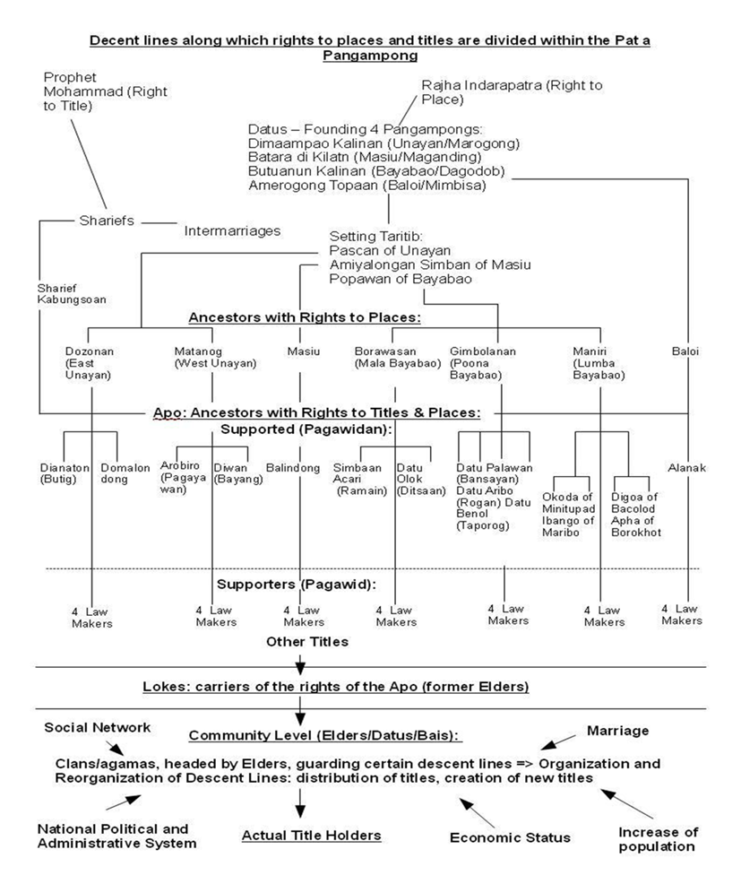
Fig. 1 Descent Line Divisions and Hierarchies in the Pat a Pangampong sa Ranao (Four States of Lanao) along with the divisions of their right to place and titles. Birte Brecht-Drouart states that, “the elders choose new titleholders, not only on the ground of their genealogical connections.” See Birte Brecht-Drouart (2011). “The Influences of the National Question and the Revival of Tradition on Gender Issues Among Maranaos.” PhD. Thesis, Goethe Universität, Frankfurt Am Main, p. 191.

Fig. 2 shows the structural chart of the Four Pangampongs of Lanao or Four States of Lanao. According to Sultan Monsing Macabando, the political structure of the Four States of Lanao is like the political structure of the Philippines national government which has executive branch, legislative branch, and judiciary branch. The fifteen now sixteen panoroganans or the sixteen royal houses of the royal sultans are the chiefs of the executive powers of the Four States of Lanao, and the twenty-eight houses of peers or the duwa pulo ago walo a m’babaya ko taritib are the policy/law makers or the legislative bodies of the Four States of Lanao. The house of the ‘ulamās’ constitutes the judiciary powers of the Four States of Lanao. The Four States of Lanao has the house of the council of elders equivalent to an executive secretary and judiciary, the house of four landmark sultanates, the house of the ladies, and the house of board of advisers. The four landmark sultanates were the places of intersection and demarcation of sultanates, known as the Pat a Inged a Kiasosoludaan o Bangsa o Pat a Pangampong sa Ranao. The house of the ladies were the titled ladies i.e. bai-a-labi, potri-[Maamor], paramata, bai-a-labi-a-gaus. Bai-a-labi was the highest ranking title among the royal titles for ladies. “The ‘ulamā’ were classified into three groups: imāms, kalis (Arabic qādīs for judge), and gurus.” The imāms, kalis, and gurus officiate the spiritual, social and religious affairs of the Four States of Lanao. They were also the religious and spiritual leaders of the agama (community). According to Sultan Monsing Macabando, the Four States of Lanao had askars and warriors. They were the military units or army, and the peace keeping forces of the Four States of Lanao. Nagasura T. Madale says that the Four States of Lanao have pananalsilas (the reciters of genealogy). The pananalsilas wrote the genealogy of the ruling classes of the Lanao Sultanate. This genealogy was known as salsila. The pananalsilas memorized the content of the genealogy and they recite the lines of descent in the genealogy during the crowning ceremony of the royalties and royal wedding ceremony. The members of the ruling clans and the commoners refer to their salsila to trace up the roots of lineage and the blood-line connections of a prospect bride and groom.
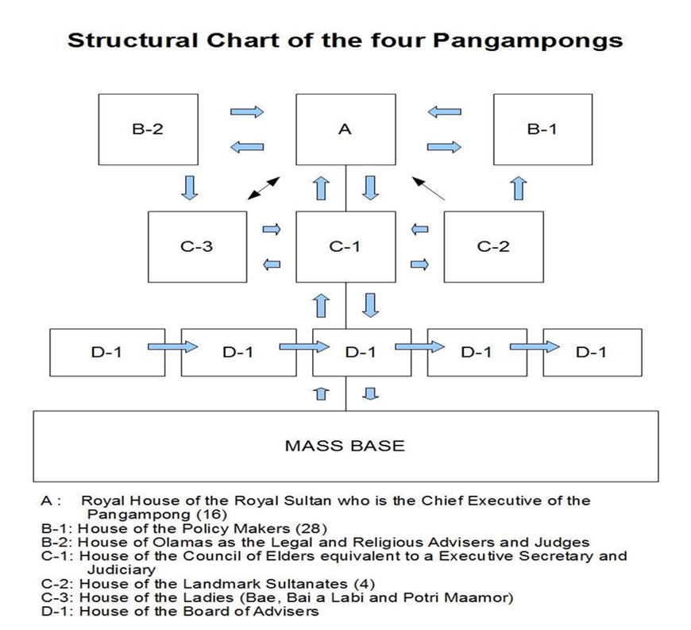
Fig. 2 Structural Chart of the Pat a Pangampong sa Ranao (Four States of Lanao). Source: Sultan Monsing Macabando, Chairman of the Marawi Sultanate League, 2017. Marinaut, Marawi City.

The Traditional Laws and Islamic Laws of the Lanao Sultanate

The Agama Court of the Maranaos in the Philippines in the 17th century and today differs from the Sharī’ah Court in other countries where Sharī’ah (Islamic Law) is enforced. The Agama Court of the Maranaos applied both the customary laws and Islamic Law in settling cases judicially. The sultan and the datu administered the Agama Court. Usually, the sultan appoints a deputy such as radia-muda and datu-kali or kali (Arabic qādī, for judge) to assist him in settling judicial matters.
The procedure before Agama Court was rather simple to follow. The complainant may either file his case orally or in writing. If the kali found sufficient cause for action, the kali called the defendant to appear before the Agama Court so that he will be asked to answer the complaint filed against him. Trial and hearing were marked by simplicity. The plaintiff will be asked to state his case and present evidence. In any case, if the plaintiff cannot produce any witness or evidence to support his claim, then the defendant, if he denied the claim will be required to take an oath. In the olden days, on judgement and execution, the datu or kali executed judgement due to their power and influence. If and when the decision of the Agama Court was contrary to the law and custom. Appeal may be lobbied by the defendant to higher datu, and sultan.
According to Mamitua Saber and Mauyag T. Tamano, there are two laws governing the Maranao society: “(i) The Adat Laws which are customary laws, and (ii) the kitab or Islamic Laws [Sharī’ah Laws] introduced to the society along with their religion.” Adat Laws are composed of taritib and igma (Arabic, ijmā). Mamitua Saber and Mauyag M. Tamano defined taritib as “ordered ways” or “established ways” while igma as “ordinance.” Adat Laws, taritib and ijmā are synonymous and interchangeable. Collectively, both taritib and igma refers to the Adat Laws which govern the social, political, and cultural aspects of the Maranaos. The Adat Laws also define the social and cultural relation of different agamas (villages).
Mamitua Saber and Mauyag M. Tamano explain that kitab are composed of “(i) the purkan meaning “pathway” (i.e. the right way) containing the legal and moral provisions of the holy Qur’ān; and (ii) the minahad containing the codes based upon the purkan by Prophet Muhammad (pbuh). The kitab is shared by the Maranaos with the rest of the Islamic World.” In this respect, kitab refers to the divine teachings of Allāh (swt). Sharī’ah Law [Islamic Law] is a universal law which guides the social, moral and spiritual aspects of the Muslims. Mamitua Saber and Mauyag M. Tamano state that “there are provisions of the taritib and igma which are enforced in all the “Four States” of [Lanao] of the Maranaos. Still others have very limited application to a pangampong (state) or to an agama unit.”
The Four States of Lanao refer to the Four Pangampongs of Lanao Sultanate, namely: Pangampong of Bayabao, Pangampong of Unayan, Pangampong of Masiu, and Pangampong of Baloi, of which, these pangampongs (states) where the provisions of taritib and igma and being enforced. Mamitua Saber and Mauyag M. Tamano explains that the jury used kias as their legal reference in settlement of case. Kias refers to a precedent in the settlement of a previous case. In the past, the ruling datus may legitimately requested an accused to come the Agama Court (State Court) for the investigation of the case which the accused was involved. Prior to the inception of modern government, the widespread punishment imposed by an aggrieved party were: saop (vengeance); and rabai (pillage). Mamitua Saber and Mauyag M. Tamano explain that “the former” [i.e. vengeance] is still rampant when the modern authority failed to interfere or when the traditional offices lost control of the feuding families. Islam outlaws the sinful acts of vengeance and pillage.”
Penalties for Crimes and Penalties for Fornication
Mamitua Saber and Mauyag M. Tamano state that in the past, penalties imposed for crimes and fornication were:
1. Kitas (death penalty by execution);
2. Olol (enslavement for women convicts of high crimes);
3. Radiam (stoning of convicts in adultery and incest crimes); and
4. Kapangangawid (“honourable” settlement with fine and compensation).

The penalty for zina or fornication and incest is radiam (stoning to death) of the perpetrators. However, according to Mamitua Saber and Mauyag M. Tamano, kitas, olol and radiam are no longer practiced “except in very rare cases in isolated areas.” While, kapangangawid “is still popular and often tolerated or accepted in the extra-legal settlements by the modern constitutional officers of the law.”
It is likely that kitas, olol, and radiam were used as punishments for specific crimes since the inception of the Lanao Sultanate, these punishments were no longer in used when the modern government was introduced in the Philippines during the American regime in the Philippines. According to Musib M. Buat,
...During the American regime effort had been made to codify Muslim Law [Sharī’ah] and Adat Law of the Philippines. Act 787 which is the organic Act of the Moro province provided for the codification of Muslim Law and Custom (July 1, 1903). Act No. 1283 has also provided for the enactment of law to amend the substantial application of Philippines civil law and criminal law so as to modify and suit its application in accordance with the customary laws of the Muslims (June 13, 1905). Act No. 2520 also provided for the modification of the application of laws whenever the parties were Muslims. The provision of these Acts are not carried out. The new Civil Code Act 78, merely exempts the Muslims from the requirements of law such as solemnization of marriage. The only substantive law which recognizes Muslim Customary Law is Republic Act No. 394 which recognizes Muslim divorce for a period of twenty years (June 18, 1948).

The new Civil Code Act 78 exempts the Muslim Filipinos from the requirements of the Philippines Constitution law on solemnization of marriage because of Islamic injunctions on polygamous marriages which was allowed in Islamic Law.
Code of Muslim Personal Law of the Philippines P.D. 1083
Azizan Abdul Razak explains about the book of Michael O. Mastura, in the introduction of his book Code of Muslim Personal Law of the Philippines.
The Code of Muslim Personal Law of the Philippines P.D. 1083 is the first Muslim law recognized by the Philippine Legal system. The process of the codification of this law started in 1973 when the Memorandum Order No. 370 was issued to create a research staff for the codification of Philippines Muslim Personal Law. On April 1974, the Draft Code for the Administration of Muslim Law was presented to President Marcos. It was recommended that a Presidential Code Commission would review the draft and submit the substantive aspect of Muslim Personal Law. On April 22, 1974, the Judiciary Code Committee of the Supreme Court invited the research staff to discuss the matter. On December 23, 1974, the Presidential Code Commission was created under Executive Order No. 442. The Office of the Research Staff was directed to serve as a commission secretariat.

In 1973, President Ferdinand Marcos catered the special needs of the Muslim Filipinos in the Southern Philippines. This was one of the great achievements of President Ferdinand Marcos during his regime despite of his being portrayed by his political enemies as dictator and tyrant.
Azizan Abdul Razak states that “after four years working, the Code P.D. 1083 was officially published in the Official Gazette Vol. 73, no. 20, 1977. Its date of effectivity was February 4, 1977. And the code had never been implemented until October 1985.” The Code P.D. 1083 was implemented in 1985. It is likely that the Lanao Sultanate’s Sharī’ah Laws and Adat Laws (traditional laws) continue to operate until 1985. It was only in the 20th century when finally this code was in used in the Philippines.
According to Azizan Abdul Razak, the contents of P.D. 1083 are: Provisions on Marriage and Divorce; Provisions on Succession; Provisions on Wills; Provisions on the Sharī’ah Court; Provisions on the Agama Arbitration Council; Provisions on Jurisconsult in Islamic Law; Provisions on Muslim Holidays; Provisions on Communal Property; Provisions on Customary Contract; Provisions on Conversions; Provisions on Bigamy; and Provisions on some offenses committed by Muslims. Azizan Abdul Razak quotes Michael Mastura,
[The] compilation of Muslim Personal Law of the Philippines has underwent various challenges and opposition of both Muslim and Christian groups. Philippines as the only Roman Catholic state in Southeast Asia and the Pacific cannot easily recognize Islamic Legal Institution in its own territory, in which the concept of separation of church and state is upholding. While a Filipino Muslim is not very happy with the kind of law going to be introduced because it only deals with the Muslim family relation and inheritance.
Criminal punishment such as radiam (stoning to death) for people who were proven guilty of adultery is not part of the provisions of P.D. 1083. Criminal Law is dealth with under Philippines Constitution. Overall, P.D. 1083 only deals with the Muslim family relation and inheritance as mentioned. On settling criminal cases before the introduction of Philippines government, the Agama Court of the Maranaos has officials, “they practice trial-by-jury composed of a council of datus, one of whom is a law-consultant called kali, and the contesting parties are represented by counsels called wakils.”This means that the Maranaos had established an institution where it settles criminal cases and disputes.

Findings and Analysis
This paper primary concern is to explore the Islamicity of Lanao Sultanate in the 17th century. Thus, it is imperative to know whether the Lanao Sultanate was an Islamic state in the 17th century or not. According to Amir Hassan Siddiqqi, to constitute a state, four elements are essential: territory, population, organization, and sovereignty. He explains further that, “Islamic state differs fundamentally from all other states” when it comes to the 4th element of state which is sovereignty. He further explains that, “no state can be termed independent state unless it enjoys sovereignty.” In this respect, the Four States of Lanao or Lanao Sultanate were sovereign states. They had traditional laws such as taritib and igma which guide their socio-political affairs.
In this view, the territories of Lanao Sultanate comprises of four states i.e. Unayan, Masiu, Bayabao, and Baloi. The socio-political organization of the Lanao Sultanate consists of “fifteen Royal Houses whose leaders assume the authority, powers, control and supervise over their respective state. The fifteen Royal Houses are assisted by the twenty-eight Houses of Peers (Policy Makers) whose duties and responsibilities is to legislate local customs, traditions, and laws subject to the joint concurrence of the Royal Houses, Council of Elders and Board of Advisers.” Thus, the Lanao Sultanate met the requirements to form an Islamic state as explain above respectively.
According to Jastaniah Abdulaziz Saddiq, “the Islamic state can be defined as a state in which authorities, organizations, individuals, and groups accept Islam as their religion and enforce its instructions in all aspects of life.” Based on this definition, the authorities and the citizens of the Lanao Sultanate in the 17th century were Muslims, however, the Lanao Sultanate in the said century had non-Muslim citizens who were the slave classes who were under the protection of their masters. These slave classes converted to Islam by marrying Muslims. In this view, Jastaniah Abdulaziz Saddiq argues,
The Islamic state can also be defined as the state of Allāh (swt) on earth, because the state’s leadership, authorities, and people believe first, that Allāh is the one and only one who is to be worshipped, obeyed, and followed; and secondly, Prophet Muhammad (pbuh) is Allāh’s servant and messenger. He was sent to all people on earth to inform them about the oneness of Allāh; to ask them to submit themselves to the will of Allāh; and to teach them how to worship, obey, and please Allāh (swt) as avoid his displeasure. He taught them how to govern and be governed; and how to build, direct, and guide their relations with other.

The oneness of Allāh is mentioned in the Qur’ān, when Allāh said: “Your God is One God; there is no God save Him, the Beneficent, the Merciful.” He also says: “Lo! We have sent thee (O Muhammad) as a witness and a bearer of good tidings and a warner.” These verses mentioned-above clearly indicate that there is only one God, and His commandments written in the holy scripture, the Qur’ān, and the Prophet Muhammad’s (pbuh) instructions are to be obeyed by Muslims at all times in every facet of their lives. Muslims were reminded by God to recognize their God and Prophet Muhammad (pbuh) who conveys good tidings and guides people to the right path. In this respect, Allāh says in the Holy Qur’ān: “O, Ye who believe! Obey the messenger, and render not your actions vain.” Abdulhamid Mitwally says,
The Qur’ān and the Sunnah contain the basic principles and the general guidelines concerning all aspects of life (social, economic, political, cultural, administrative as well as religious). These principles and guidelines must be both enforced and followed in the Islamic state. Further, details about the various aspects of life are determined in accordance with the need of Muslims to meet requirements of place and time as long as these details do not violate the essential directions of the Qur’ān and the Sunnah.

This means that the social, economical, political, cultural, administrative, and religious aspects of Ummah (Muslims community) must be in conformity with the teachings of Qur’ān and Sunnah of Prophet Muhammad (pbuh). The Qur’ān and Sunnah guide the way of life of Muslims. According to Sultan Monsing Macabando, the establishment of the Lanao Sultanate in the 17th century was guided by the Qur’ān and the Sunnah of the Prophet Muhammad (pbuh). Sultan Monsing Macabando explains,
‘…Sabab sa so manga tao sa Magindanao ago sa Ranao na diran kalayaman so kadato a sultaniya na aya den piyakandato iran na so Sharīf Kabunsuan a pagam-paganay a sultan sa Magindanao. Ini pangenda-onian pun so ka-a-ator o kapag-inged a taritib ago igma, ago ini pasodian ko kataro o Allāhutaala, ‘Hay manga manusia mata-an inaden ko sekano sa phoon a mama ago babay go bialoyaken sekano am’bara-barang a bangsa ago pithikaloksan ka ankano maka khikilalai, sa mataan a aya lebi a seselaan rekano sii ko Allāh na sa maaleken rekano ka mataan a so Allāh i matao ago Kaip.’ Isa pen a katharo o Allāh, ‘Hay sekano wa miamaratiyaya onotinio so Allāh goso manga Nabi ago so kiyaopakatan rekano a pedio a ini diniyo ron sa kadatu.’ Giya duwa ini a katharo o Allāhutaala i piasodan o manga apo tano ko kiamba-ali ran ko taritib ago igma a ini tanor iran ko kaphaginged ago so kiapaka tindeg o manga kadatu iran sa Ranao. Orian nian a so kiyasuwa-a o manga datu sa Magindanao ago sa inged a Ranao ko kadatu a sultaniya, na so Sharīf Kabunsuan na liowasian so sultan sa Magindanao ko wata iyan a so Saripada Makaalang a wata iyan ko Bae Angintabo a Meranao na gioto i-aya paganay a miya sulutan sa Magindanao na Meranao ka so Saripada Makaalang na aya ina iyan na so Bae Angintabo a Meranao na aya ama iyan naso Sharīf Kabunsuan a Arab-Malayo…’

The above writings is in Maranao language, here its English translations,
…The people of Magindanao and Lanao were not familiar with the sultanate system of leadership, so, because of this, they asked Sharīf Kabunsuan to become the Sultan of Magindanao-Lanao. Sharīf Kabunsuan taught them how to organize the state based on the taritib and igma, and based on the words of Allāh, “O mankind! We created you from a single (pair) of a male and a female and made you into nations and tribes that ye may know each other (not that ye may despise each other). Verily the most honoured of you in the sight of Allāh is (he who is) the most righteous among you. And Allāh has full knowledge and is well acquainted (with all things).” Another word of Allāh [verse in the Qur’ān] is, “O you who believe! Obey Allāh and obey the Messenger, and those of you who are in authority.” These are the two words of Allāh which our ancestors [the Maranaos] referred to when they framed the taritib and igma of Lanao, and when they organized their state [Lanao], and the various ranks of people who possessed authority during the time they founded the sultanate system in Lanao. Finally, when the people of Magindanao and Lanao learned the sultanate system of leadership, Sharīf Kabunsuan, then, enthroned his son, Sharīf Makaalang as the Sultan of Magindanao-Lanao. He was his son from his Maranao wife [from Malabang Lanao], Bae Angintabo. Sharīf Makaalang was the first Maranao sultan who became the Sultan of Magindanao-Lanao. His mother was Bae Angitabo, a Maranao, and his father was Sharīf Kabunsuan, an Arab-Malay…

The above statement tells us the historical, cultural, and the Islamic bases of the foundation of Lanao Sultanate. Historically, Lanao was part of the Magindanao Sultanate which had two political offices, one was established in Magindanao, and the other in Lanao, presently Lanao del Sur. The social, economic, political, cultural, administrative as well as religious aspects of the Maranaos were guided by the teachings of the Qur’ān and the Sunnah of the Prophet Muhammad (pbuh). An Islamic state has unique characteristics. According to Jastaniah Abdulaziz Saddiq, ‘a state can be identified as an Islamic state when followings are met:
1. It [the state] believes in no other God but Allāh, and Muhammad is His servant and messenger;
2. It emphasizes the Qur’ān and Sunnah (together forming Sharī’ah) as the two most important sources of its religion;
3. It aims at spreading the faith and the religion;
4. It emphasizes equality and justice among all people, regardless of any differences such as language, colour, race, birth, or class;
5. It emphasizes the concept of brotherhood and peace to govern the relations among the Muslim communities and peace to govern, and guide its relations with other states;
6. It gets itself ready to defend its religion, people, interests, and boundaries against attack;
7. It accepts the principle of referring all matters that cause dispute to the Qur’ān and Sunnah for their final judgement;
8. It applies the concept of shūrā (mutual consultation) to decide Muslim affairs; i.e. selection of the head of state, proclamation or war, etc.; and
9. It enjoins the right and forbids the wrong.

In this view, I will explain each of the above-mentioned categories which characterizes an Islamic state in view of exploring the Islamicity of the Lanao Sultanate in the 17th century.
1. It [the state] believes in no other God but Allāh, and Muhammad (pbuh) is His servant and messenger. In this context, the inception of the Lanao Sultanate in the 17th century was a result of Islamic influences. First, by Sharīf Kabunsuan, an Arab-Malay who became the first Sultan of Magindanao and Lanao. He taught the people of Magindanao and Lanao the tenets of Islam and established Islamic leadership. Second, the religion of the people of Magindanao and Lanao was Islam.
2. It emphasizes the Qur’ān and Sunnah (together forming Sharī’ah) as the two most important sources of its religion. In this respect, the Muslim people of the Lanao Sultanate in the 17th century referred to the Qur’ān and Sunnah as important sources of principles of their religion-Islam. This explains why they successfully defended their religion from the Spanish invaders during the colonization period in the 17th century. “…The Maranao people defied foreign domination of their land even as early 1639 against the Spaniards. In a sense, the Spanish-Maranao conflict was part of the conflicts in Europe between Christianity and Islam.”
3. It aims at spreading the faith and the religion. In this view, the Lanao Sultanate in the 17th century had organized learning institutions in spreading the tenets of Islamic religion The ‘ulamā’ (learned scholars) transformed their homes as houses of learning. According to Sultan Monsing Macabando, by the 17th century the inhabitants of Lanao learned the principles and tenets of Islam from their ‘ulamā’, whose main function is to propagate and spread Islamic knowledge to the community. The individuals who are interested to learn Islam seek knowledge from the ‘ulamā’. There was no madrasah (Islamic and religious school) in the past as it is today because the residence of the learned ‘ulamā’ becomes school of learning for the students who want to learn Islamic teachings.
(4) It emphasizes equality and justice among all people, regardless of any differences such as language, colour, race, birth, or class. In this case, one of the functions of the sultan is to render equality and serve justice to people.
(5) It emphasizes the concept of brotherhood and peace to govern the relations among the Muslim communities and peace to govern, and guides its relations with other states. In this view, the Maranao societies can best be understood from the aspect of their cultural practices. The Maranaos emphasized to observe kambangensa (blood kinship and strong bond and unity of clans and families) because kambangensa maintains the solidarity of clans, families and the whole society as a whole.
The foundation of kambangensa are katotonganay (blood-bond by having a common ancestor), and kambabalaiya (marriage-relationship).These two are pulling the maratabat (pride) of the Maranaos to show mutual support to each other. One way to describe this concept is when some members of the family face difficulty, the whole bangensa (clan) is naturally affected and eventually their pride pushes every member of the clan to render support… In the datu-ship/sultanate [system], when one member of the clan intends to bear the throne of a sultan or any sub-position lower than sultan, the whole family member of the clan give their support to any of their member who is going to be enthroned because a sultan who came from sadorog a bangensa (one line of descent) is believed to bring maratabat (honour) to the whole clan and its members. This means that the Lanao Sultanate in the 17th century emphasized the strong collectiveness and unity of people. The founders of the Lanao Sultanate had common ancestors. Thus, they valued the equality of powers, unity and strong brotherhood between and among them. This also explains why the Lanao Sultanate had multiple inter-dependent sultans so that the political powers are resided and distributed to people. In fact, the citizens and the members of the community elected their representatives to represent them in various socio-political ranks in the Lanao Sultanate in the 17th century. There was no monopoly of power in the Lanao Sultanate as well as there was no single centralized power ruling the entire state of Lanao Sultanate.
(6) It gets itself ready to defend its religion, people, interests, and boundaries against attack. In this case, the Lanao Sultanate in said century had successfully defended its religion-Islam, the Maranao people, their interests and homeland from the Spanish colonizers in the 17th century. The Muslims in Mindanao fought the might of Spain for a period of 377 years. This is the longest war fought in the history.
(7) It accepts the principle of referring all matters that cause dispute to the Qur’ān and Sunnah for their final judgement. In this view, the inception and foundation of said sultanate in said century went through a series of meetings and conferences called upon by different datus of different states of Lanao to arrive at consensus, and then later they finalized the establishment of Lanao Sultanate. The social, political and religious matters which were being implemented in Lanao Sultanate went through consultation between and among the traditional leaders, the people, and their representatives.
(8) It applies the concept of shūrā (mutual consultation) to decide Muslim affairs; i.e. selection of the head of state, proclamation or war, etc. In this view, the Lanao Sultanate in the 17th century emphasized the use of shūrā (mutual consultation) in every decision-making affecting the state. Kapakipemumusawira is a Maranao term which means consultation among people. Its root word is shūrā which is an Arabic word. The igma (consensus) of the sultans, datus and other traditional leaders of the Four States of Lanao was one of the bases of the decision-making process of the Four States of Lanao, namely, Bayabao, Unayan, Masiu and Baloi.
(9) It enjoins the right and forbids the wrong. In this case, through the teachings of the religious leaders of the community, the state serves as agency in leading the people to righteousness and the traditional leaders forbid the people from committing wrongdoings. These are few of the most important functions of Lanao Sultanate in the 17th century. In a nut shell, the Lanao Sultanate met these nine enumerated characteristics of an Islamic state as explained each above, respectively.

CONCLUSION
This research finds that the Lanao Sultanate in the 17th century laws was based on Islamic laws along with the traditional laws of the Maranaos of the Lanao Sultanate. The Lanao Sultanate in the 17th century was an Islamic state based on this premise and findings of this study. The Lanao Sultanate met the functions of an Islamic state.

Sultan Monsing Macabando. Brief History of the Balindong Dynasty of the Dominion State (Sultanate) of Pungampongan-a-Masiu. Marawi City, Philippines: Marawi Sultanate League, 2005, p. v.
Sohayle M. Hadji Abdul Racman. “The Political Legitimacy of the Lanao Sultanate in the 17th Century with Special Reference to the Political Thought of al-Māwardī.” PhD, Universiti Brunei Darussalam, Brunei Darussalam, 2018. See in appendix A of the thesis. My interview with Sultan Monsing Macabando at Ranao Radio Broadcasting and TV (RRTTV) System Corp., SMA Bldg., Kotha Pangarungan, Nurhaya Village, Marawi City. On February 15, 2017. Broadcasted at RRTV System from Feb. 16 to 30, 2017. Uploaded in the Youtube by Somayah Magarang on March, 5 2017. Access on Youtube: Sohayle H. Abdulracman. RRBTV System Corp. owner: Bombit Adiong, the Governor of Lanao del Sur.
Ruurdje Laarhoven. “We are Many nations: The Emergence of Multi-Ethnic Maguindanao Sultanate.” Philippine Quarterly of Culture & Society, Vol. 14, no. 1, pp. 32-53, 1986.
Sohayle M. Hadji Abdul Racman. “The Political Legitimacy of the Lanao Sultanate…” In Appendix A.
Ibid.
Ibid.
Ibid.
Ibid.
Ibid.
Ibid.
Sultan Monsing Macabando. Brief History of the Balindong Dynasty of the Dominion State (Sultanate) of Pungampongan-a-Masiu. Marawi City, Philippines: Marawi Sultanate League, 2005, p. 70.
Ibid.
Sohayle M. Hadji Abdul Racman. “The Political Legitimacy of the Lanao Sultanate…” In Appendix A.
Ibid.
Shinzo Hayase. Mindanao Ethnohistory Beyond Nations, Maguindanao, Sangir, and Bagobo Societies in East Maritime Southeast Asia, ed., by Antonio de Castro. Manila: Ateneo De Manila University Press, 2007, pp. 44-47.
Ibid. p. 47.
Cesar Adib Majul, et al., edited by Peter G. Gowing and Robert McAmis. The Muslim Filipinos. Manila: Philippines, Solidaridad Publishing House, 1974, pp. 27-28.
Sohayle M. Hadji Abdul Racman. “The Political Legitimacy of the Lanao Sultanate…” In Appendix A.
Ibid.
Republic of the Philippines, the Province of Lanao del Sur, Mindanao official website: https://lanaodelsur.gov.ph/about/history/. Accessed, August 1, 2017.
Sultan Monsing Macabando. Brief History of the Maranao Mindanao, Maranao Salsila (Genealogy) Their Origin, Vol. 1. Marawi City, Philippines: Marawi Sultanate League 2008, p. 18.
Ibid., p. 19.
Ibid., p. 19.
Sohayle M. Hadji Abdul Racman. “The Political Legitimacy of the Lanao Sultanate…” In appendix A.
Sohayle M. Hadji Abdul Racman. “The Political Legitimacy of the Lanao Sultanate…” In Appendix A.
Mamitua Saber, “Maranao Resistance to Foreign Invasions.” The Maranao Man by Maranao men in Mindanao Art & Culture, no.4 Mindanao, a non-periodical series. Marawi City, University Research Center, Mindanao State University, p. 23, 1980.
Helen R. Tubangui, et al. The Filipino Nation A Concise History of the Philippines, ed. Jim Haskins. Philippines: Grolier International Inc., 1982, p. 109.
Mamitua Saber and Mauyag M. Tamano. “Decision-Making and Social Change in Rural Moroland.” Marawi City: Mindanao Journal, XII, 1-4, p. 68, 1985.
Ibid., p. 68.
Nagasura T. Madale. Maranao. Manila: National Commission for Culture and the Arts, 2002, p. 6.
M. Saber and M. M. Tamano, op. cit., pp. 62-63.
B. Brecht-Drouart. “The Influences of the National Question and the Revival of Tradition on Gender Issues Among Maranaos.” PhD. Thesis, Goethe Universität, Frankfurt Am Main. 2011. B. Brecht-Drouart quotes from S. M. Macabando.
Ibid., p. 181.
Ibid., p. 214.
Ibid., p. 213.
Sohayle M. Hadji Abdul Racman. “The Political Legitimacy of the Lanao Sultanate…” In appendix A.
Ibid.
N. T. Madale. Maranao…, p. 3.
Musib M. Buat. “Survey of Filipino Muslim Adat (Customary Law) and Role of Agama Court.” Mindanao Journal, Mindanao State University, Vol. 1, p. 104, 1977.
Ibid., p. 99.
Ibid., p. 100.
M. Saber and M. M. Tamano, op. cit., pp.116-117.
Ibid., p.117.
Ibid., p.117.
Ibid., p.117.
Ibid., p. 118.
Ibid., p. 118.
Ibid., p. 118.
M. M. Buat, op. cit., p. 100.
Azizan Abdul Razak. Syariah, Adat, and Common Law Amongst the Maranaos of Southern Philippines, An Exploratory and Comparative Studyy. Teaching and Research Exchange Fellowships Report No.7. Pasir Panjang, Singapore: Southeast Asian Studies Program, 1991, p. 5.
Ibid., p. 5.
Ibid., p. 6.
Ibid., p. 5.
M. Saber and M. M. Tamano, op. cit., p. 162.
Amir Hassan Siddiqqi. “Early Islamic Society, Culture and Government,” Mindanao Journal, Vol. II no. 2, University Research Center, Mindanao State University, Marawi City, October-December, p. 43, 1976..
S. M. Macabando. Brief History of Maranao Mindanao…, pp. 19-20.
Ibid., p. 18.
Ibid., p. 19.
Jastaniah Abdulaziz Saddiq. “The Islamic State in the Light of the Qur’ān and Sunnah.” PhD Thesis, Ann Arbor Michigan, University Microfilm International A Bell & Howell Information Company, Claremont Graduate School, 1982, p. 1.
Melvin Mednick. Some Political Problems of Moro History and Political Organization in The Muslims Filipinos, ed. by Peter G. Gowing & Robert McAmis. Manila, Philippines: Solidad Publishing House, 1974, p. 24.
Jastanaih Abdulaziz Saddiq. The Islamic State in Light of the Qur’ān and Sunnah. PhD Thesis, University of Colorado. Ann Arbor, Michigan, USA: University Microfilms International A Bell & Howell Information Company, 1982, p. 1.
Qur’ān, 2:163.
Qur’ān, 48:8.
Qur’ān, 48:33.
Abdulhamid Mitwally, Mabdi’ Nizām al-Hukm fil Islām, 4th ed. Alexandria: Ma’aāref, Est, 1978, p. 34.
S. M. Macabando. Brief History of the Balindong Dynasty…, p. 68.
Ibid., p. 68.
Qur’ān, 49:13.
Qur’ān, 4:59.
English translation from Maranao language from S. M. Macabando’s work in Brief History of the Balindong Dynasty…, p. 68.
J. A. Saddiq. The Islamic State in the Light of the Qur’ān and Sunnah…, pp. 2-3.
Ibid., pp.2-3.
S. M. Macabando. Brief History of the Balindong Dynasty…, p. 68.
J. A. Saddiq, op. cit., pp. 2-3.
S. M. Macabando. Brief History of the Balindong Dynasty…, p. 68.
J. A. Saddiq, op. cit., pp. 2-3.
Sohayle M. Hadji Abdul Racman. “The Political Legitimacy of the Lanao Sultanate…” In appendix A.
J. A. Saddiq, op. cit., pp. 2-3.
Sohayle M. Hadji Abdul Racman. “The Political Legitimacy of the Lanao Sultanate…”In appendix A.
J. A. Saddiq, op. cit., pp. 2-3.
Jamel R. Cayamoden. “The Pat a Pengampong A Ranao: A Study on the Emergence of Lanao Sultanates in the 21st Century.” M.A. Thesis, University of the Philippine, Diliman, Quezon City, 2007, pp. 33-34.
B. B. Drouart, op. cit., pp. 177-178.
Sohayle M. Hadji Abdul Racman. “The Political Legitimacy of the Lanao Sultanate…” In appendix A.
J. A. Saddiq, op. cit., pp. 2-3.
M. Saber and M. M. Tamano…, pp. 25-26.
M. Saber and M. M. Tamano…, p. 33.
J. A. Saddiq, op. cit., pp. 2-3.
Sohayle M. Hadji Abdul Racman. “The Political Legitimacy of the Lanao Sultanate…” In appendix A.
J. A. Saddiq, op. cit., pp. 2-3.
S. M. Macabando. Brief History of the Maranao Mindanao…, p. 19.
J. A. Saddiq, op. cit., pp. 2-3.
Sohayle M. Hadji Abdul Racman. “The Political Legitimacy of the Lanao Sultanate…” In appendix A.

