TP53 GENE STATUS IN THE PRESENCE OF ALLICIN IN NNK-INDUCED PANCREATIC CANCER ALBINO RATS
ABUTU, P. O, MINARI, J. B, OBI, J. C, OKORIE, A. N AND UGWU, P. I
Corresponding Author E-mail- abutuphillip@gmail.com Tel:+2348065516842
Departments of Medical Laboratory, Paelon Memorial Hospital, Victoria Island, Lagos.
Abstract
Pancreatic cancer (PC) is the fourth most lethal form of cancer in Western society, with mortalities closely mirroring incidence and an overall 5-year survival of less than 7%. Traditional medicine which involves the use of herbs has been used to treat various types of cancer and this has been found to be effective with minimal or no side effects. This ressearch was aimed at evaluating the chemo preventive effect of extract of the active ingredients of garlic (Allicine)on Nitrosamines induced pancreatic cancer in rat.
Allicine was extracted from garlic by crushing the garlic in an ethanol and inject into the HPLC column. Agarose gel electrophoresis was used to analyze deoxyribonuleic acid (DNAs) extracted from the pancreatic tissue of the experimental mice while haematoxylin and eosin staining was used for histological assay.
There was a significant reduction in the weight of the experimental animals that were administered with NNK. The animals administered with extract (allicin) also show a reduction in weight. Normal control animals were seen to have gained weight.
DNA bands obtained from agarose gel electrophoresis suggested a possible NNK induced damage which was prevented to a certain degree owing to the effect of the allicin.
Histological assay revealed the presence of neoplastic hyperplasia which is more prominent in the histological sections of the pancreatic tissue of the rats which were not treated with allicin.
This study has shown that allicin could be used as a treatment against NNK induced pancreatic cancer in white albino rats at the right concentration.
INTRODUCTION
Cancer is a cellular disease and mainly caused by the misbalance of the normal cellular growth maturation and multiplication (Mathew et al., 2010). A cell becomes cancerous when it grows uncontrollably and quickly. In most cancers, this process leads to tumors growth. Tumors are abnormal growth of tissue resulting from uncontrolled cell growth. They are either malignant or benign. Not all tumors are cancerous; benign tumors for instant do not spread to other parts of the body (NCI, 2014). Benign tumors are no threat to life, but malignant tumors are cancer. Cancer cells can spread to other tissues and organs near the tumor. They can likewise spread to other sites in the body through the bloodstream or lymphatic system. The process of this spreading is referred to as metastasis. People of all ages get cancer, but it is most common in people older than 55 (ATDSR, 2009). One out of three people will get cancer at some point in their life. Cancer cells show high rate of mutation, chromosomal abnormalities, genomic instability, and abnormal patterns of chromatin modifications (Klug et al., 2010).
Cancer are of several types and according to Adebamowo and Ajayi in 2000, there are over 100 various types of cancer, and each is classified by the type of cell that is initially affected, and these include cervical cancer, skin cancer, leukameia, lung cancer, prostate cancer, and so on (Ozbay and Nahta, 2011). Pancreatic cancer among other types of cancer is the fourth (4th) most common cause of death globally and is common in both men and women. Pancreatic cancers are more likely to exist in men than in women, and among African-Americans than among whites (Croasta, 2015). Cigarette smoking is one of the risk factors of pancreatic cancer. Diet and obesity have also been linked to the cancer of the pancreas. People who do not exercise much and who are obese are more likely to develop pancreatic cancer (Michaud et al, 2001). In addition, those who eat diets low in vegetables and fruits and high in red meat and fat are more likely to be diagnosed with the disease (Michaud et al., 2005). Alcohol consumption is also considered a risk factor for pancreatic cancer. Long term, heavy drinking leads to chronic pancreatitis, which is a known risk factor for pancreatic cancer (American Cancer Society).
Pancreatic cancer (PC) is the fourth most lethal form of cancer in Western society, with mortalities closely mirroring incidence and an overall 5-year survival of less than 7% (Kleef eta.l, 2016; waddell et a.l, 2015). Early disease detection is rare, and of those patients diagnosed with early-stage disease, only 20% of patients are eligible for surgery, the only potential cure to date with the remainder in advanced stages of the disease. Pancreatic cancer carries an extremely poor prognosis, with 90% of pancreatic cancers being malignant and the 5-year survival rate after diagnosis hovering at 5%. Less than 20% of patients are candidates for surgical resection; therefore, chemotherapy and radiation therapy (RT) remain the only other treatment options (Wason et al., 2013). In the United States each year, over 30,000 people are diagnosed with pancreatic cancer. Europe sees more than 60,000 diagnoses each year. Because pancreatic cancer is usually diagnosed late into its development, the five-year survival rate after diagnosis is less than 5%.
In Nigeria, the burden of cancer is appreciable with about 100,000 new cancer cases being reported in the country each year. A desk review of the level of occurrence and pattern of distribution of different cancer types in Lagos and Ibadan cancer registries over a 5-year period (2005-2009) was carried out by Awodele et al in 2011. The results obtained showed a total number of 5094 cancer patients registered between 2005 and 2009 in both Lagos (60%) and Ibadan (40%) cancer registries. Breast cancer accounted for the majority of cases (20.2%), followed by cervical cancer (7.9 %), fibroid (4.4%), liver (4.4%), stomach (4.3%), brain (3.9%), and pancreas (3.8%).
Pancreatic cancer and other cancer related diseases have been treated using surgery, chemotherapy, and radiation therapy, or a combination of these. But despite these options, cancer remains associated with high mortality (Alawode, 2013). This is basically due to difficulties in early diagnosis, exorbitant cost of treatment. And owing to these shortcomings, there is need for other therapeutic options which will increase the chances of survival of pancreatic cancer patients with minimal or no side effects of treatment.
Therefore, traditional medicine which involves the use of herbs has been used to treat various types of cancer and found to be effective and at the same time presenting minimal or no side effect (Sofowora, 1984; Sowemimo et al., 2011). Plants produced many anticancer drugs such as taxanes and vincristine and still serve as a veritable source of new products through the use of standard bioassay methods (Alawode, 2013). A good example of plants and herbs use for cancer treatment includes Momordicacharantia, Basil Ocinum, Annona muricata, Pawpaw leaf, Caspiumfrutescens, Ananascomosus (Pineapple), Allium cepa (Onion), Allium sativum (Garlic), Chenopodium ambrosioides (Worm wood), Bryophyllumpinnatum (Resurection plant or Life plant), Vernonia amygdalina (Bitter leaf) and others (Mao et al., 2011). However, the anti-cancer properties of Allium sativum (Garlic) is not yet fully elucidated scientifically.
Allium sativum, known as Garlic, is a species in the onion genus, Allium. Its close relatives include the onion, shallot, leek, chive, and Chinese onion. Allium sativum is a bulbous plant. It grows up to 1.2 m (4 ft) in height. It produces hermaphrodite flowers. It is pollinated by bees and other insects. With a history of several thousand years of human consumption and use, garlic is native to Central Asia and northeastern Iran, and has long been a common seasoning worldwide. It was known to Ancient Egyptians and has been used both as a food flavoring and as a traditional medicine (Simonetti,1990).
Inactivation of the TP53 gene on chromosome 17p is present in approximately 50%–75% of pancreatic cancers, and inactivation of the TP53 gene almost always occurs via intra-genic mutation combined with loss of the second allele. The p53 protein has a number of important functions in the cell, including regulation of the G1-S cell cycle checkpoint, maintenance of G2-M arrest, and the induction of apoptosis. Loss of p53 function allows cells to survive and divide despite the presence of damaged DNA, leading to the accumulation of additional genetic abnormalities (Vogelstein et al., The aim of this study is toevaluate the chemo preventive effect of extract of the active ingredients of garlic on Nitrosamines induced pancreatic cancer in rat.
3.1 MATERIALS
Allicin extracted from Garlic at the Cllege of Medicine of Lagos University hospital, Idi araba, Ethylene Diamine Tetraacetic Acid (EDTA) from Klincent laboratories, Mumbai, India. Tris from BDH Chemicals Limited Poole England. All other reagents used were of analytical grade and prepared in all glass distilled water.

3.2 EXPERIMENTAL ANIMALS
The 30 adult mice used for this study were obtained from the College of Medicine, Lagos University Teaching Hospital, Idi- araba, Lagos, Nigeria. The animals were housed in standard clean mice cages at 25 degree celsus., fed with standard pellet and tap water ad libtum. They were maintained under uniform conditions of natural photocopied (12 hours light/dark cycle), and humidity (61-95%). Experiment was carried out in the animal house of the University of Lagos, Lagos, Nigeria in accordance with the rules in Nigeria governing the use of Laboratory animals as acceptable internationally (WMA Helsinki Declearation, 2008).
3.3 GARLIC PREPARATION AND EXTRACTION OF ALICIN
Allium Sativum, known Garlic was cleaned and peeled in the Biochemistry Laboratory of the College of Medicine of Lagos University Teaching Hospital. It was cut into pieces and crushed in 70% ethanol for 30minutes.

3.31 METHOD OF EXTRACTING ALLICIN USING HPLC
- The outer skin of the garlic cloves was peeled and crushed in a garlic press.
- The pressed garlic was then collected in a beaker and mixed thoroughly.
- 700-900mg of the pressed mash was weighed and transferred to a 50ml centrifuge tube.
- Using a volumetric pipette, 25ml of cold water was delivered to the sample and immediately capped and shaken vigorously for 30s.
- Heat transfer was avoided from hands by holding the tube cap while shaking.
- An additional 25ml of cold water was added and shaken for 30 more seconds to dilute and mix the solution.
- Each sample is filtered through 0.45µm glass filter into HPLC vial and capped for injection

3.4 HAEMATOLOGICAL AND EOSIN STAINING PROCEDURE
CUT-UP: The pancreas tissues and organs were cut and placed inside a well labeled tissue embedding cassette.
PROCESSING: The tissue was then processed using a 24 hour automatic tissue processor for a time ranging from 17-19 hours. The tissue processor contains 12 beakers, 10 glass beakers and 2 thermostatically controlled electric metal beakers containing paraffin wax.
EMBEDDING: The tissues after being processed were embedded using an automatic embedding center. Embedding is a process of submerging a tissue in a metal plastic disposable embedding mould paraffin wax. The paraffin wax becomes solidified when it is cold. This provides a support medium for the tissue during sectioning.
MICROTOMY: Sections of the tissue were cut using a microtome. The sections were cut and placed in a clean grease free slide which was then placed on a hotplate for 30minutes in order for sections to adhere to the slides.
STAINING METHOD: The staining method used is the H and E staining method. This method is used because it is used to demonstrate the general structure of the tissue.
PROCEDURE: The sections underwent the following processes during staining:
- Sections were dewaxed in xylene.
- Sections were placed in descending grades of alcohol, that is, from absolute alcohol > 95%alcohol >70% alcohol> water.
- They were stained in Haematoxylin for 10 minutes.
- Rinsed in water
- Differentiate in 1% acid alcohol (a dip).
- Rinsed in water
- Blued in tap water for 5minutes.
- Counterstained in 1% of Eosin for 2-5 minutes.
- Rinsed in tap water.
- Dehydrated using ascending grades of alcohol (70% alcohol > 95% alcohol > absolute alcohol).
- Cleared in Xylene
- Mounted on distyrene plasticizer and xylene (D. P. X.).
- Finally, the sections were viewed under a photomicroscope.

3.5 DNA EXTRACTION PROTOCOLS
The DNA protocol used for this study was a modified procedure of Nishiguchi et al 2002. This is described below.
- Water bath was turned on and adjusted to 50˚C.
- A small amount of tissue (0.5 cm) was chopped as finely as possible with a sterile scalpel blade and transferred to a labeled 1.5ml microcentrifuge tube
- 600 µl of TNES buffer and 35 µl of Proteinase- K (20 mg/ml) was added to the sample and mixed by inverting the tube several times.
- The samples were incubated overnight (24 hours) at 50˚C. The samples were occasionally mixed by inverting the tubes.
- 1/10 volume of 5M potassium acetate was added and mixed very well by inverting the tubes. Incubation on ice was done for 30 minutes.
- Tubes were span at 10,000 rpm for 10 minutes and supernatant was transfered to a new tube.
- An equal volume of phenol chlorofoam was added to the supernatant
- The solution was mixed by inverting the tube several times.
- The mixture was centrifuged at 5000 rpm for 5minutes. The upper aqueous phase containing nucleic acids and the lower organic phases were separated.
- The upper phase was transfered to a new tube.
- An equal volume of chloroform was added to the tube and mixed by inverting the tube several times.
- The mixture was centrifuged again at 5000 rpm for 5 minutes.
- The upper aqueous layer layer was transfered to a new tube.
- An equal volume of (˜8000 µl) of cold 100% ethanol was added and gently mixed by inverting the tube a couple of times.
- The mixture was centrifuged again at 5000 rpm for 5 minutes.
- The upper aqueous layer was transferred to a new tube.
- An equal volume of (˜800 µl) of cold 100% ethanol was added and gently mixed by inverting the tube a couple of times.
- The samples were centrifuged at full speed speed of 14,000 rpm for 20minutes at 4˚C.
- The supernatant was poured away, taking care not to dislodge the pellet of DNA.
- The DNA pellets were washed in 700 µl of 100% ethanol. The ethanol was poured off and the samples were briefly centrifuged to keep the pellet at the bottom of the tube.
- The DNA pellets were washed with 70% ethanol as above. After removing the 70% ethanol, the samples were briefly centrifuged to get the last of the ethanol to the bottom of the tube and the remaining ethanol was pippette off.
- The samples were left to air dry for 30minutes.
- As soon as the sample was dry, the DNA was re-suspended in 200 µl of Sterile Tris-EDTA.
3.6 PROCEDURE FOR GEL ELECTROPHORESIS
- 0.8g of agarose gel was weighed into a conical flask containing 100 ml of 0.5% TE buffer.
- The mixture was heated on a hotplate until the agarose dissolved.
- The dissolved agarose was carefully brought down using insulated gloves. When the melted gel has cooled to about 60˚C, ethidium bromide was added to a final concentration of 0.5µg/ml. The gel solution was mixed thoroughly by swirling gently.
- While the melted agarose solution was cooling, an appropriate comb for forming the sample well in the gel was positioned 0.5-1.0 mm above the plate so that a complete well is formed when the agarose is added to the mold.
- The warm agarose solution was poured into each of the mold.
- The gel was allowed to polymerize completely (20-45 minutes at room temperature).
- A small amount of electrophoresis bufffer (10X tris – borate- EDTA buffer) was then poured on top of the gel, after which the combs were carefully removed.
- The electrophoresis buffer was then poured off and gel was mounted on the electrophoresis tank.
- The gel was placed into the electrophoresis device and enough electrophoresis buffer was poured to cover the gel to a depth of approximately 1 mm.
- The DNA samples were mixed with the loading dye in the ratio 1: 5.
- The DNA sample mixtures were loaded into the wells of the submerged gel using a disposable micropippette.
- The lid of the gel tank was replaced and electrical connections made so that the DNA will migrate toward the positive anode (red lead). A voltage of 1-5 V/cm was used.
- When the DNA samples with dyes had migrated for a sufficient distance through the gel, electrical current was turned off.
- The leads and lid were removed from the gel tank.
- The gels were transfered with a spatula to the transilluminator.
- The ultraviolet light in the transimullator was turned on and the photograph of the gel was taken immediately.
- The transilluminator ultraviolet light was turned off immediately after photoghraphing the gel.

CHAPTER FOUR
RESULTS
A dissected white albino rat showing various internal organ is shown on plate 3. The Pancreas of this dissected albino rat was carefully removed for laboratory studies. The histological section of a pancreas administered with LD50 of 350g/ body weight of Nicotine Derived Nitrosamine Ketone (NNK) and 200g/ body weight of allicin is shown on plate four. The histological section shows an area of fatty degeneration and fibrosis. This platefive shows the histological section of a pancreas that was administered 200g/ body weight of allicin. This section shows a degenerated fibrosis.
The histological section of a pancreas that was administered with LD50 of 350g/ body weight ofNicotine Derived Nitrosamine Ketone (NNK) and 200kg/ body weight of allicin once a week is shown on plate 6. It was observed that this area shows a parenchymal of the tissue appearing normal.
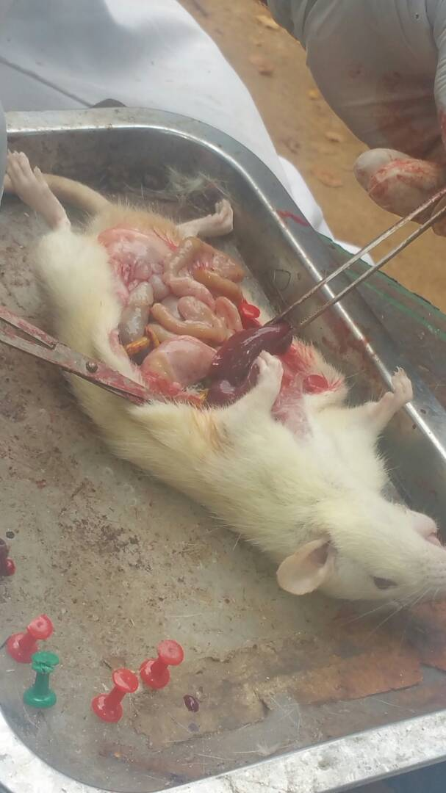PLATE 3: A dissected white albino rat showing various internal organs.

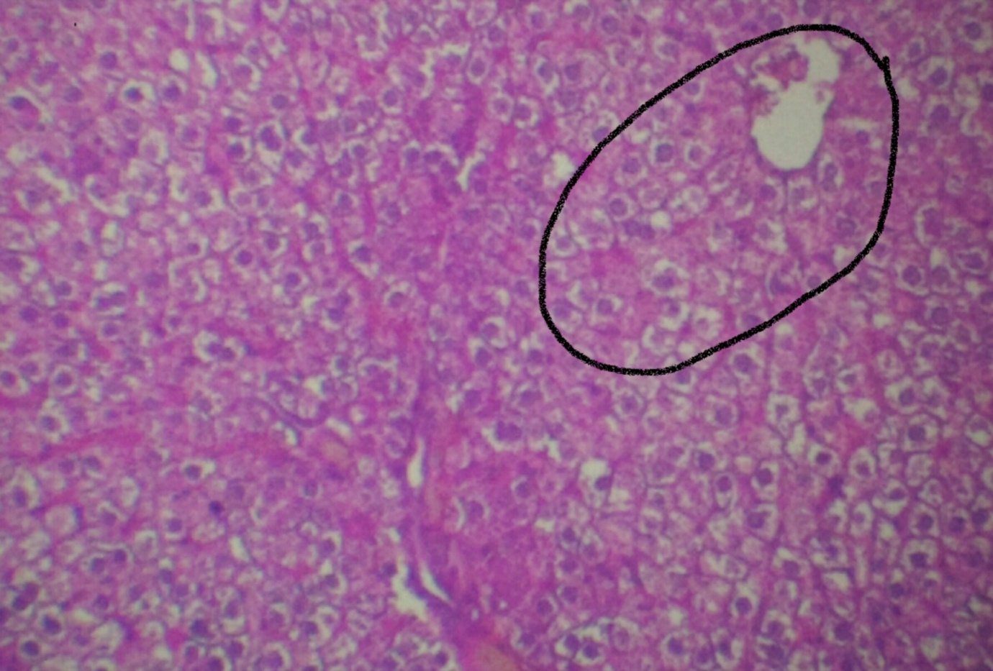
PLATE 4: Histological section of a Pancreas of Daily doseage of NNK and Extract (HE-100X).
NE1: Rats that received LD50 of 200g/ body weight of allicin and LD50 of 350g/ body weight of NNK.

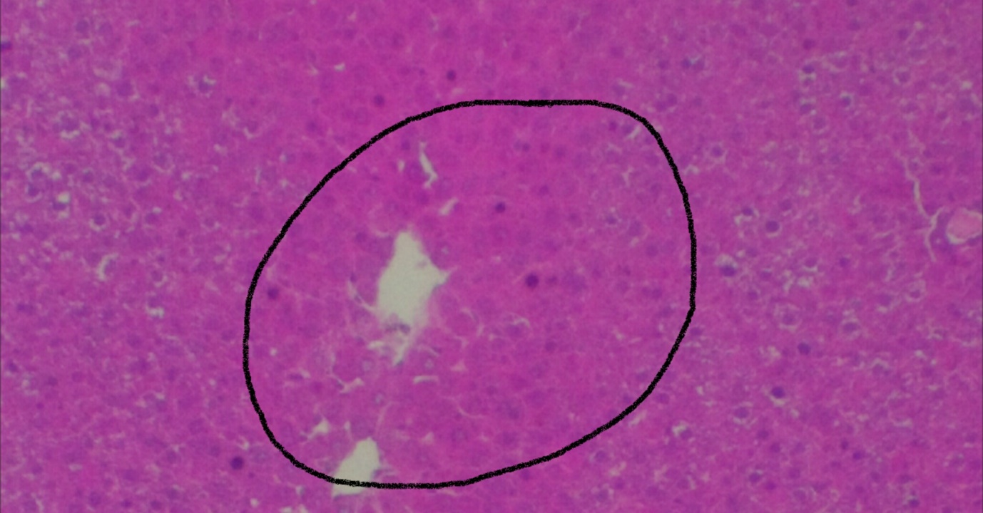
PLATE 5: Histological section of a Pancreas of doseage of Extract only (HE-100X). E1: Rats that received 200g/ body weight of allicin

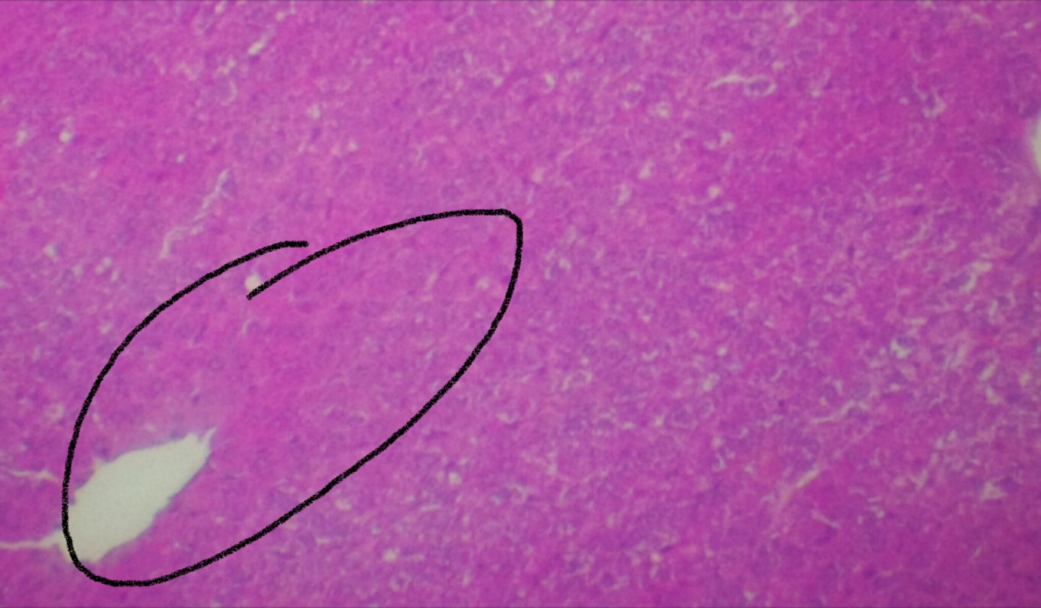
PLATE 6: Histological section of a Pancreas of doseage of NNK with Extract (HE-100X).
NE: Rats that received 350g/ml of NNK and 200g/ml of allicin once.

Plate seven shows the histological section of a pancreas that was administered with LD50 of 350kg/ body weightNicotine Derived Nitrosamine Ketone(NNK) only. An area of steatopancreatitis with severe necrosis, fibrosis and ballooning degeneration was observed. The histological section of a pancreas that was administered 250mg/ body weight of Metformin (Drug) and an LD50 of 350kg/ body weight is shown on plate eight with an improved morphological appearance of the pancreas. Plate nine shows the histological section of a normal pancreas (Normal Control) that was administered with distilled water. The electrophoretic bands of DNAs obtained from Nicotine Derived Nitrosamine ketone pancreatic induced rats treated with allicin is shown on plate 10.
Table 4 shows the effect of NNK and allicin on the weight of NNK induced pancreatic rat. There was a statistical difference (p < 0.05) in the weight gained between week 1 and week 4. There was a significant reduction in the rat that was administered with LD50 of 350g/ body weight of NNK. The reduction in the weight of the animals that were administered with 200g/ body weight of allicin.The quantitative analysis of DNA obtained from the tissue of NNK pancreatic induced rat is shown on table 7. This shows the purity of the DNA obtained in the various section between 1.56-1.86.
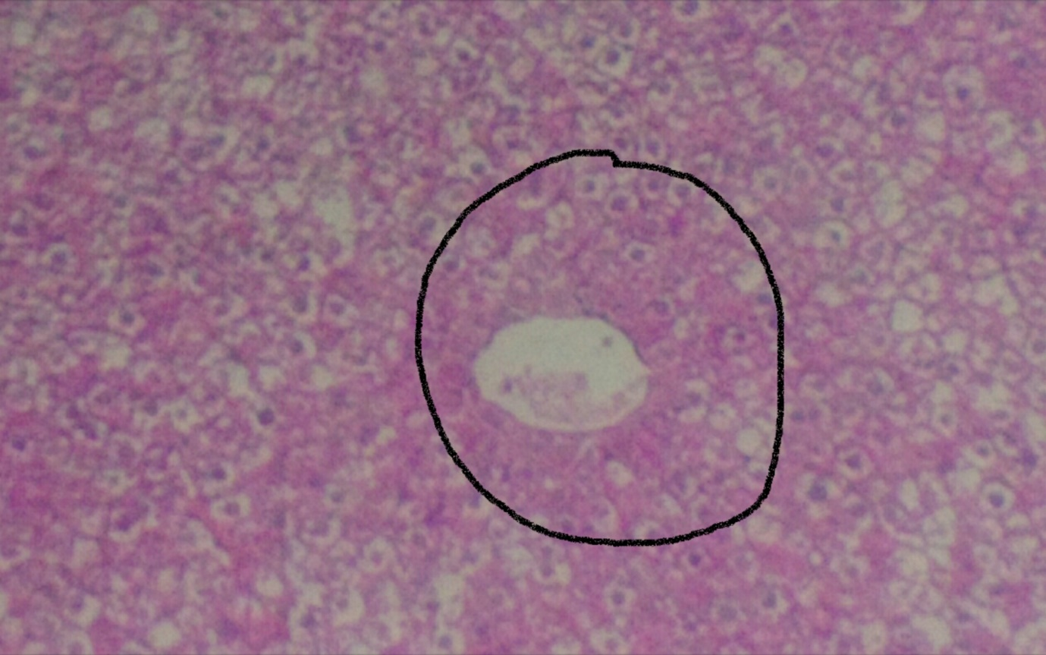
PLATE 7: Histological section of a Pancreas of doseage of NNK (HE-100X).
N1: Rats that received LD50 of 350g/body weight

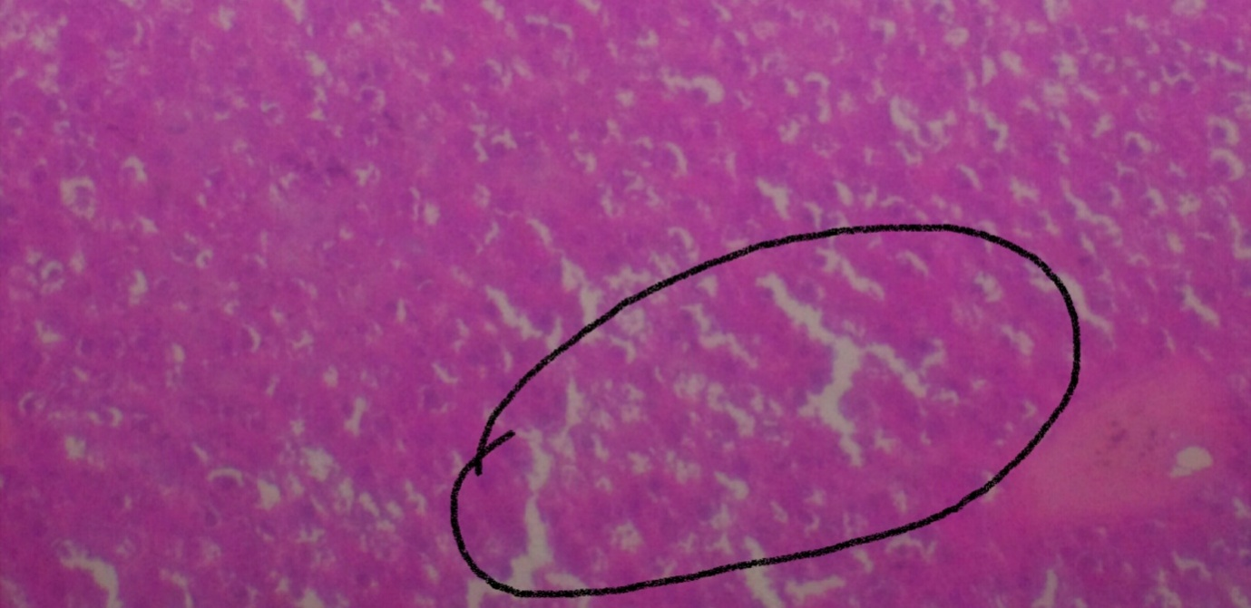
PLATE 8: Histological section of a Pancreas of Daily doseage of drug (Metformin) and NNk (HE-100X).
NED: Rat that received 200mg/ body weight of drug and 350g/ body weight of NNK.

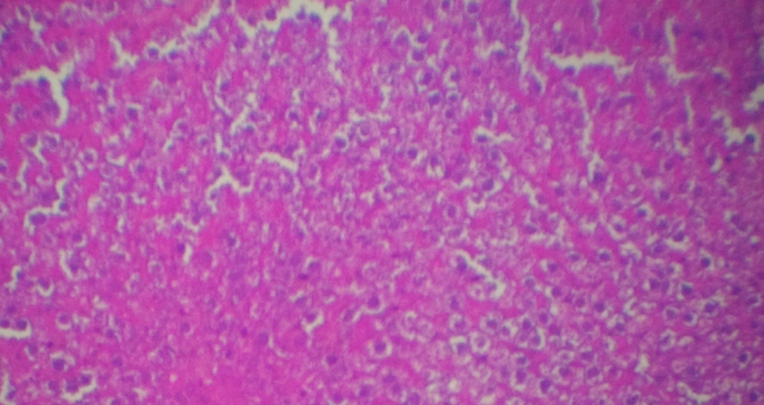
PLATE 9: Histological section of a normal Pancreas (HE-100X).
NC: Rats that were administered distilled water (Normal control)

FIGURE 9: The weight of the albino rat and the duration in week within 4 weeks.

Table 7:QUANTITATIVE ANALYSIS OF DNA OBTAINED FROM THE TISSUE
OF NICOTINE DERIVED NITROSAMINE KETONE OF PANCREATIC INDUCED RAT.
 | Conc. (mg/ml) | A260/280 | A260/230 | A230 | A260 | A280 | A340
NE2 | 860 | 1.86 | 1.82 | 0.393 | 0.717 | 0.368 | 0.030
NC1 | 2059 | 1.78 | 1.77 | 1.108 | 1.809 | 1.002 | 0.103
ND1 | 2354 | 1.70 | 1.68 | 1.196 | 1.950 | 1.120 | 0.160
N1 | 1071 | 1.54 | 1.50 | 1.120 | 1.905 | 1.102 | 0.122
NED1 | 2068 | 1.75 | 1.76 | 0.978 | 1.723 | 0.982 | 0.119
NE3 | 3027 | 1.56 | 1.53 | 1.654 | 2.523 | 1.616 | 0.410
NE1 | 2204 | 1.75 | 1.78 | 1.104 | 1.801 | 0.994 | 0.075
E1 | 1974 | 1.67 | 1.63 | 1.208 | 1.976 | 0.994 | 0.351
NE1: NNK and daily dose ofallicin.
NE2: NNK and weekly dose ofallicin.
NE3: NNK and allicin dose (Just once).
ND1: NNK with Drug
NED: NNK with daily allicin
N1: NNK only.
E1: Extract only.
NC1: Normal Control
NED

LD
N1
NE3

E1
NE1
NC
ND
NE2

LDSD
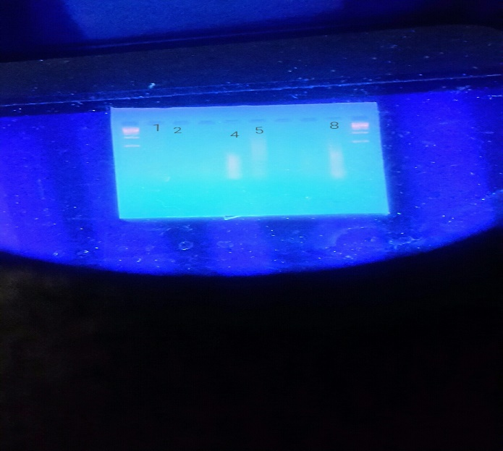
PLATE 10: Electrophoretic bands of DNAs obtained from the pancreatic tissues of NNK induced pancreatic cancer traeted with allicin in albino rats
KEY:
1: NNK with daily dose of allicin.
2: NNK with allicin (Just once)
3: NNK with weekly dose of allicin
4: NNK with weekly dose of allicin
5: Allicin Only
6: NNK only
7: NNK with Drug
8: Normal Control
9: DNA Ladder

DISCUSSION, CONCLUSION AND RECOMENDATION
Pancreatic cancer (PC) is the fourth most lethal form of cancer in Western society, with mortalities closely mirroring incidence and an overall 5-year survival of less than 7% ((Jemal, et al., 2008)). Traditional medicine which involves the use of herbs has been used to treat various types of cancer and this has been found to be effective with minimal or no side effects. Cancer of the pancreas is a genetic disease. Sporadic cancer of the pancreas is frequently associated with the activation of an oncogene, KRAS and the inactivation of multiple tumor suppressor genes including p53, DPC4, P16 and BRCA2 (Hruban et al., 1998). However, the majority of pancreatic cancer occur sporadically, a minority has been shown to aggregate in families and has aided our understanding of pancreatic tumorigenesis. Allicin, an active component of garlic has been demonstrated to possess powerful anti-cancer effects. Allicin helps to protect against variety of cancers including those associated with the stomach, colon, breast and pancreas.
The effect of allicin on Nitrosamine induced pancreatic cancer rats were evaluated. Nitrosamine is a well-known potent carcinogen which is known to cause pancreatic cancer.
The electrophoretic gel of the rat administered with 350g/ body weight of Nicotine Derived Nitrosamine ketone with daily dose of allicin (NED) of Plate 10 shows that there was no amplification of DNA. This would be because of the NNK must have distorted the DNA sequence and the concentration of the drugs is not enough. Thus, the TP53 is distorted and not able to amplify the DNA (Bond-Smith et al., 2012).
Nicotine derived Nitrosamine Ketone with daily dose of allicin (NE1) of Plate 10 appears that there is no amplification of DNA as the allicin could not correct the damage done by the NNK.
According to Jain et al., 2007, It appears that the LD50 0f 350kg/ body weight of NNK and daily dose of 200kg of allicin (NE3) of plate 10 shows that the concentration of extract given was effective to correct the damage done by the NNK although it’s a smear in which the DNA must have been contaminated with RNA.
A concentration of 200kg/ body weight of allicin (E1) of plate 10appears that there was an amplification of DNA. Thus, the plant does not induce any form of DNA damage.
It was observed that concentration of 350kg/ body weight of Nicotine Derived Nitrosamine Ketone (N1) as seen in plate 10 shows no amplification of DNA because the DNA is damaged. The NNK must have distorted the DNA sequence which makes the TP53 not to amplify the DNA.The electrophoretic band of rats administered with 350kg/ body weight of Nicotine Derived Nitrosamine Ketone with weekly dose of 200kg/ body weight of allicin (NE2)as shown on plate 10 appears that there was no amplification of DNA as the concentration of the allicin is not enough to correct the damage done by the NNK.
Nicotine derived Nitrosamine Ketone and 250mg of Metformine (ND) of plate 10 appears no amplification of DNA which is because of the drug being administered at a high concentration which must have distorted the DNA sequence which makes the TP53 not to amplify the DNA.
The rat administered with distilled water (NC) of plate 10 shows an amplification of DNA contaminated with RNA.
The reduction in the weight of the animals that were administered with LD50 of 350kg/body weight of NNK as shown on table 4 indicates the carcinogenic activity of the NNK. The reduction in weight of the animals that were administered 200kg/body weight as shown in table 4 indicates the possible toxicity of the garlic extracts (Allicin). This extract might have metabolized to a toxic end-point thereby interfering with gastric function and decrease the efficiency of food conversion. The normal control could be as a result of the action of the immune system playing a vital role.
According to Hoffman et al., 2005, one important consideration is the possibility of endogenous formation of NNK from nicotine provides additional carcinogen exposure. This agrees with plate 7 above which shows an area of steatopancreatitis with severe necrosis, fibrosis and ballooning degeneration. The survival rate of the rats that received NNK is shorter than the rats that received water. This support the hypothesis that NNK is a causative agent of cancer.

REFERNCES
Adebamowo, C.A. and Ajayi, O.O. (2000). Breast cancer in Nigeria. West African Journal Medicine 19,179-194.
Agency for Toxic Substances and Disease Registry (ATSDR), 2009. Chemicals, Cancer and You. Atlanta, Georgia, is a federal public health agency of the US Department of Health and Human Services. ATSDR partners with communities across the nation to increase knowledge about toxic substances, reduce the health effects of toxic exposures, and protect the public health.
Alawode, T. T. 2013. An overview of the anti-cancer properties of some plants used in traditional medicine in Nigeria. International Research Journal of Biochemistry and Bioinformatics. 3(1): 7-14.
America Cancer Society. 2007 Cancer Facts and Figures. Atlanta, GA: America Cancer
American Cancer Society. 2012. Breast Cancer facts and figures. American Cancer Society,
American Cancer Society. 2014. Key Statistics about Cancer
American Cancer Society. 2015. Cancer Facts and Figures. Atlanta, Ga: American Cancer
Awodele, O., Adeyomoye, A.A., Awodele, D.F., Fayankinu, V.B and Dolapo, D.C. (2011). Cancer distribution pattern in south-western Nigeria. Tanzanian Journal of Health Reseach. 13(2): 1-8.
Bond-Smith, G., Banga N., Hammond T. M. 2012. Imber Clinical Journal. 344: 2476 -2477.
evaluation and anticancer screening of rhizomes of Kaempferia galangal Linn. International Research Journal of Pharmacy. 9:1-2.
Hruban, R. H, Petersen, P. K. Ha, S.E. 1998. Kern Genetics of pancreatic cancer from genes
International Atlanta.
Jemal, A., 2008. Cancer statistics, 2008. Cancer Journal of Clinic. 58:71–96.
Mao, J. J, Palmer, C. S., Healy, K. E., Desai, K and Amsterdam, J (2011). Complementary and alternative medicine use among cancer survivors: a population-based study. Journal of Cancer Survivorship. 5: 8-17.
Mathew, B., Vijayabaskarb, M., Mathewa, G.E., Thomas, K.M (2010). Phytochemical
Michaud D.S, Giovannucci E, Willett W.C, Colditz G.A, Stampfer M.J, Fuchs C.S (2001). Physical activity, obesity, height, and the risk of pancreatic cancer. JAMA. 286:921-9.
Michaud, D.S., Skinner, H.G., Wu, K., Hu, K., Giovannucci, E., Willett, W.C., Colditz, G.A., and Fuchs, C.S (2005). Dietary patterns and pancreatic cancer risk in men and women. Journal of National Cancer Institute. 97:518-524.
National Cancer Institute. 2014. Defining Cancer. Reviewed 10 June 2014. www.cancer.gov/cancertopics/cancerlibrary/what-is-cancer of families. Surgery oncology of clinical journal. 7 (1) 1-23.
Ozbay, T. and Nahta, R (2011). Delphinidin inhibits HER2 and Erk1/2 signalling and suppresses growth of HER2 overexpressing and triple negative breast cancer cell lines. Basic and Clinical Research. 5: 143-154.
Simonetti, G. (1990). Schuler, S., ed. Simon & Schuster's Guide to Herbs and Spices. Simon and Schuster, Inc
Society.
Sofowora, A. (2008). Medicinal plants and traditional medicine in Africa. John Wiley and sons LTD, Pp.1-10.
Sowemimo, A., Van de4. Venter M., Baatjies L, and Koekemoer T (2011). Cytotoxicity evaluation of selected Nigerian plants used in traditional cancer treatment. Journal of Medicinal Plants Research. 5(11): 2442-244.

