**Analysis Network Voltage Control with The Regard of wind turbines and the Placement of PMU with Using Algorithm DAPSO**

Hamed Nezhadsattari*a,Aref Jalili iranib

*Department of Electrical Engineering, Ardabil Branch, Islamic Azad University, Ardabil, Iran*

*\*aEmail: h.nezhadsattari@yahoo.com*

*bEmail: arefjalili@gmail.com*

**Abstract**

In this article, we investigate an event that extensively effects on profile of voltage by occurring in a distribution system when a wind turbine is disconnected from the network. This issue is considered as an urgent condition in performance of distribution network and also placing of Pharos Measurement Units (PMUs) in the system is performed using DAPSO algorithm for complete visibility and then it is performed to control voltage immediately by using regulation that at here this is implemented by tap changer trans and disconnect able loads. Finally, to test the system, kinds of experiments are performed so that influence of different parameters will be observed on efficiency of model.

***Keywords:*** Voltage Control; Wind Turbine;Locating PMU; DAPSO Algorithm

------------------------------------------------------------------------

* Corresponding author.

E-mail address: h.nezhadsattari@yahoo.com

**1. Introduction**

Shortage of electrification networks in remote regions and high cost of connection of these regions to global system due to unfavorable geographical situation double necessity of use of other energy resources such as renewable energies as independent sources from network in these regions. Presence of disperse production resources can increase possibility of occurrence of instability of voltage according to stability scope of voltage. One of these units is wind turbines that presence of these production units has various positive and negative effects on power system. Although voltage instability phenomena might occur in any part of network, voltage instability happens just in distribution part. In analyzing voltage instability, a radial line is considered which is fed by network and on the other hand feeds a load. So far, many researches have been performed about voltage control as real time and random production of wind resources by researchers. According to [1], a new approach is proposed for Connectional Voltage Control (CVC) of power systems in presence of uncertainty of power production by wind and demand amounts. Framework of CVC is dealt with the conditions in which a power system is faced with instability of voltage due to consequences of heavy events. The uncertainty present in wind power production and demand amounts are managed using a method based on scenario. One of the features of the proposed method is using role-playing of resources related to demand as an efficient control tool which decreases costs of control. Framework of proposed control in system of IEEE is implemented by 118 buses so that its use and efficiency will be shown. According to [2], by using RTUs and their sent information, accountability of load is performed in presence and influence of wind turbines. In this article, a real-time voltage control method is presented that uses decrease of load as a part of programs of demand response to keep voltage of distribution feeders in a certain scope. Since renewable production and unpredictable changes in load demand and also events of distribution network usually recognize voltage violation in some buses, real-time voltage control proposed at here is considered assuming the point that there is possibility of voltage violation in buses. It is assumed that in normal conditions, voltage control is implemented based on a voltage control program which the day before implementing programs it is planned. A random planning program is presented in [3] to plan energy and its storage in a smart distribution system with presence and high influence of wind resources. In this reference, because of prediction errors of wind production, main generator and responsive loads are considered as reserve and are participated in planning. According to [4], a recent multi-purpose SMP-OPF model is presented to optimize the issue of designing a power network connected to a wind farm by a great converter of high-voltage direct current (HVDC). The wind turbines used in this research are of doubly-fed inductive generators (DFIGs) and to achieve exact amount of production power of these turbines, their DFIG curves are used. Also in this article, uncertainty resulting from production of wind turbines is taken into account, as well. According to [5], a random operational planning method was presented to plan energy and reserve it in a smart distribution system with high-influence of wind energy. Error in predicting wind energy and prediction of demand are considered in this approach and reserve is provided by two main network generators and responsive loads. Consumers participate in both sections of energy supply and planning storage. Demand Response Presenter (DRP) decreases total of loads in order to simplify participation of small and medium loads in program of responding to demand. Planning method has been tested on a sample 83-bus distribution network during a 24-hour period. In [6] an approach is presented that uses potential of smart network to increase efficiency of voltage control in distribution systems. In [7], issue of regulating voltage is discussed well by studying effects of DG on voltage profile and performance of Stepped Voltage Regulators (SVRs) and feeder parallel capacitors. In [8], a new method is proposed to improve efficiency of voltage regulators in multiple feeders including DGs. This model is based on RTUs of each DG unit and each of capacitor’s buses that correspond with each other in a certain order. Data received from RTUs has made possible estimating minimum and maximum voltage in feeders and subsequently voltage control of feeders is made possible.

In this article, in first section model of wind turbine is discussed and then in second section voltage instability, in third section DAPSO algorithm, and in forth section PNU locating using DAPSO algorithm and estimation of voltage based on assessment of PMUs in the studied system and finally in the last section results will be presented.

**2. Wind turbine**

The power produced by each wind turbine is designated based on wind velocity. Curve of output power of wind turbine $P_{WG}$) based on wind speed $V_{WS}$ is presented in Figure (1) which is approximated with Relation (1) [9]:

 (1)

Where Vcutin, Vcoutout and Vrated are low cut-in velocity, high cut-out velocity and rated velocity of turbine based on m/s and Pwmax is maximum output power of turbine.

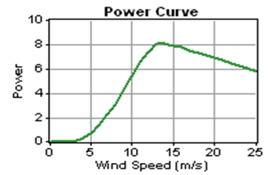

**Figure 1:** Power production based on velocity in wind turbine

**3. Voltage instability**

Instability is divided into two small and big disturbance categories [10]. In analyzing small disturbance, linear model is used and in big disturbance non-linear model is used. A power system in a certain quiescent point is called voltage-stable of small disturbance if after a small voltage disturbance it is returned to the past amount and or it is mitigated in its neighborhood. A power system in a certain quiescent point is called stable of big disturbance if after a big disturbance voltage of the system is placed in a balanced point after error. Main factors of voltage instability in initial seconds are inductive motors. If in a part of power network such as great industrial units there are many inductive motors, it is more possible that such a phenomenon occurs. Therefore, short voltage instability sometimes is called “instability of inductive motors”.

**4 . DAPSO algorithm**

According to Equations (2) and (3), for an algorithm that each particle follows two best amounts, the best response that the particle itself has obtained and the best response that other particles have obtained is that velocity of particles reaches to zero after beginning of searching and it causes their tapping in local optimums. To prevent such an issue, inertia weight coefficient in the proposed algorithm changes as following which itself is a function of other parameters.

|  |  |
| --- | --- |
| (2) |  |
| (3) |  |

In this algorithm, inertia weight coefficient is influenced by evolutionary position and is expressed by evolutionary velocity coefficient and particle swarm coefficient in Relations (4), (5), and (6):

|  |  |
| --- | --- |
| (4) |  |
| (5) |  |
| (6) |  |

Amount of Wini is the initial amount of inertia weight coefficient and based on experiences it is considered 1. At here, α andβ are considered 0.4 and 0.8, respectively.

**5. PMU location allocating using DAPSO algorithm**

In this article, DAPSO algorithm is used to optimally locate PMU. In this method, the network is completely visible by utilizing minimum number of PMUs. Position vector of each particle indicates potentially solving PMU locating problem. To determine the best particles in each repetition and using them in next repetitions in order to solve optimization problem, a fitness function is needed and vector of the best particle (a particle with the best position) in each repetition (pbest), and also vector of the best particle between different repetitions is determined by (gbest) of this fitness function. Purpose of optimal PMU locating in this article is calculating minimum number of needed PMUs for completely visibility of the network and maximizing number of alternative elements of measuring in the system. Therefore, fitness function should be in a way that the following points will be considered in it: (1) visibility of system, (2) minimization of number of PMUs, (3) maximization of number of alternative measuring elements. Alternative measuring element is defined in [11]. Fitness function considered in this article for DAPSO is expressed as Equation (7):

|  |  |
| --- | --- |
| (7) |  |

Where indicates number of visible buses; is number of PMUs and is alternative measuring element. Weights, ، and are used to select a suitable domain for each section of fitness function. Also, is number of buses of network. and are expressed as Equation (8):



|  |  |
| --- | --- |
| (8) |  |

Product of AX in Equation (7) indicates number of times which each bus of network is visible by alternation of PMU. Vector X which was defined previously shows PMU locating. Vector M is selected based on a favorable level of measurement in system.

**6. Voltage estimation according to assessment of PMUs**

Maximum and minimum voltages are calculated by each of PMUs and output results to PMU are sent as input data. To clarify the issue, assume PMUn is a PMU which is connected to a certain DG and PMUn-1 is defined as upstream PMU, that is, a PMU which is connected to upstream DG. Also, PMUn+1 is defined as downstream PMU [12]. According to Figure (2), the algorithm can be explained as following: PMUn by implementing local assessments, estimates and expresses the voltage between PMUn+1 and its node by using Equation (9):

|  |  |
| --- | --- |
| (9) |  |

Where $V_{est,n,n+1}$ is an estimation of the voltage between buses related to ${PMU}_{n}$ and ${PMU}_{n+1}$ which is calculated by ${PMU}_{n}$. $V_{n}$ is nth bus of DG which ${PMU}_{n}$ is connected to it. Delivery of active and reactive power from the bus related to ${PMU}_{n}$ to the bus related to ${PMU}_{n+1}$ are indicated as $P_{n,n+1}$ and $Q_{n,n+1}$, respectively. Also, $r_{n,n+1}$ and $x_{n,n+1}$ are resistance and reactance of the lines between buses related to ${PMU}_{n}$ and ${PMU}_{n+1}$, respectively. Final amount to estimate voltage for the distances between the buses related to ${PMU}_{n}$ and ${PMU}_{n+1}$ are calculated by the above estimated voltage and the similar estimated voltage by ${PMU}_{n+1}$ for this distance is calculated by using Equation (10):

|  |  |
| --- | --- |
| (10) |  |

Where $V_{est,n,n+1}^{F}$ is the final estimated voltage for the lines between the buses related to ${PMU}_{n}$ and ${PMU}_{n+1}$. At the next step, the voltage between ${PMU}_{n}$ and ${PMU}_{n+1}$ is estimated by Equation (11):

|  |  |
| --- | --- |
| (11) |  |

Finally, the voltages, $V_{n}$، $V_{est,n,n+1}^{F}$ and $V_{est,n,n-1}$ are sent to upstream PMU ${PMU}_{n-1}$. Since some of the calculations are performed by PMU, the transferred data and time of calculations are decreased compared to common SCADA; therefore, the proposed model reacts to the voltage changes rapidly.

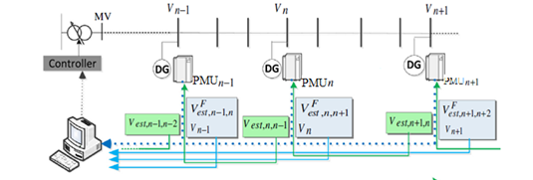

**Figure 2:** Delivery of PMU information

After the calculations related to voltage in each part of feeder, controller of the voltage regulator calculated the maximum and minimum amount of the network’s voltage. For voltage regulator in all of the buses in an acceptable scope, the difference between feeders should be lower than the scope defined through minimum and maximum amount of the network’s voltage.

**7. The studied system**

The proposed method was implemented on a real experimental system (a 20 kW radial distribution network that is shown in Figure (3). Information was presented in Table (1) over and over. This network has 27 buses and also in four points of which wind turbines were installed that has rated power of 8/1 kW. Bus 7 has 1093 kW capacity, Bus 15 has 639 kW, Bus 17 has 1740 kW and Bus 18 has 1200 kW. Changes of wind power in this area are indicated in Figure (4).

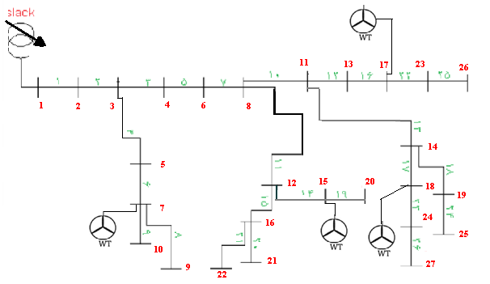

**Figure 3:** A typical distribution system for experiment

**Table 1:** Information of loads of a 27-bus network

|  |  |  |  |  |
| --- | --- | --- | --- | --- |
| Power factor | Type load | Q(KW) | P(KW) | Bus |
| 0.85 | 2 | - | - | (slack) |
| 0.9 | 3 | 460 | 840 | 2 |
| 0.85 | 2 | 340 | 980 | 3 |
| 0.8 | 1 | 446 | 790 | 4 |
| 0.85 | 2 | 184 | 598 | 5 |
| 0.85 | 2 | 600 | 610 | 6 |
| 0.85 | 2 | 110 | 1780 | 7 |
| 0.85 | 2 | 60 | 650 | 8 |
| 0.85 | 2 | 130 | 980 | 9 |
| 0.8 | 1 | 200 | 640 | 10 |
| 0.85 | 2 | 100 | 750 | 11 |
| 0.85 | 2 | 120 | 780 | 12 |
| 0.85 | 2 | 105 | 1360 | 13 |
| 0.85 | 2 | 180 | 1115 | 14 |
| 0.9 | 3 | 210 | 900 | 15 |
| 0.9 | 3 | 225 | 1200 | 16 |
| 0.8 | 1 | 300 | 600 | 17 |
| 0.85 | 2 | 180 | 840 | 18 |
| 0.85 | 2 | 95 | 720 | 19 |
| 0.85 | 2 | 120 | 750 | 20 |
| 0.85 | 2 | 365 | 730 | 21 |
| 0.85 | 2 | 320 | 1100 | 22 |
| 0.85 | 2 | 250 | 900 | 23 |
| 0.8 | 1 | 400 | 800 | 24 |
| 0.85 | 2 | 175 | 540 | 25 |
| 0.85 | 2 | 90 | 1000 | 26 |
| 0.85 | 2 | 280 | 280 | 27 |

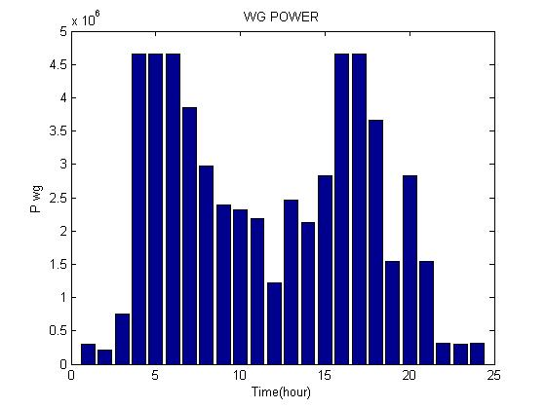

**Figure 4:** Output power of a wind turbine

In Figure (5), a 24-hour profile is presented for intended load which shows changes rate of each of kinds of loads during 24 hours.

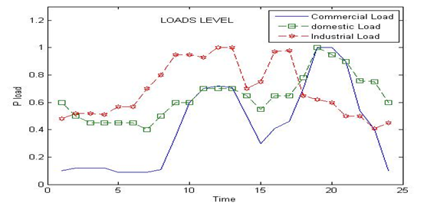

**Figure 5:** A 24-hour profile for the intended load

**8. Simulation results**

In this section, two experiments were performed. In first experiment, locating PMU was done without considering load measuring units and in second case, this issue was performed with considering load measuring units. Results are presented and compared in Table (2).

**Table 2:** Results obtained for locating PMU using DAPSO algorithm

|  |  |  |
| --- | --- | --- |
|  | Without a current measurer | With a current measurer |
| Number of PMU units | 10 | 8 |
| Installation place of PMU units | 2, 3, 7, 8, 11, 15, 16, 23, 24, 25 | 2, 6, 7, 15, 17, 23, 24, 25 |
| Number of current measurer units | 2 | 0 |
| Installation measurer of current measurer units | 10, 15 | - |
| Visibility amount | 44 | 34 |

system is visible which it is because of main condition of the system’s design in which the issue is planned with the purpose of complete visibility .Also, in a simple comparison in Table (3), it is observed that for the second case, DAPSO algorithm has better results than IPSO algorithm and also has higher convergence velocity that this algorithm is indicated in Figure (6).

**Table 3:** Results obtained for PMU locating using DAPSO and PSO algorithms (With presence of current measuring units)

|  |  |  |  |
| --- | --- | --- | --- |
|  | DAPSO algorithm | IPSO algorithm | PSO algorithm |
| Number of OMU units | 8 | 8 | 8 |
| Installation place of PMU units | 2, 6, 7, 15, 17, 23, 24, 25 | 4, 7, 8, 11, 15, 16, 19, 23 | 3, 7, 8, 16, 17, 20, 26, 27 |
| Number of current measuring units | 2 | 2 | 2 |
| Installation place of current measuring units | 10, 15 | 1 and 26 | 18 and 1 |
| Visibility rate | 38 | 38 | 44 |

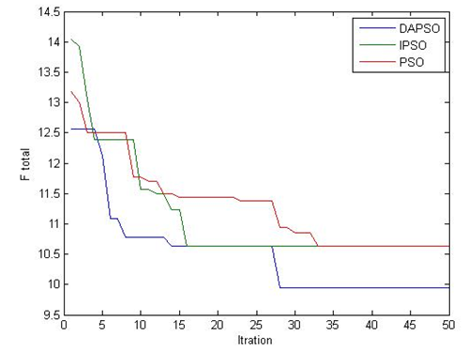

**Figure 6:** Convergence path of the system for different optimization algorithms

Now, if wind turbines work abruptly, as a result, it will experience an extensive loss. Voltage profile in all nodes for hours from 7 to 12 is shown in images of Figure (7). During this period, voltage loss in some buses is lower than 0.95 per unit. Although decrease of load at the end and middle buses on the voltage profile has higher impact but at peak hour, responsibility of load is not able to regulate voltage again; therefore, in these hours tap trances are used, as well.

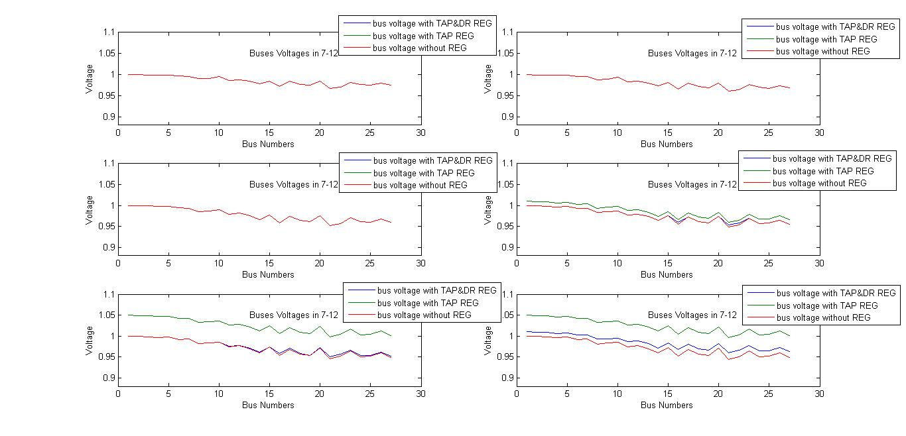

**Figure 7:** Voltages of different buses for three cases (without tap, regulator and at the same time with regulator) from 7 to 12

Voltage profile in the network before and after regulation, by considering only action of tap changer and condition of tap changer and disconnect able loads, is indicated in Figures (8) and (9) for 10 and 11 o’clock and in the other for 20 and 21. As it is indicated, at 10 and 11 there is voltage shortage in some points of the network; especially in buses 16 and 21 this voltage loss is out of allowed domain. In this case, it is observed that by using only a tap changer in this case, voltage of the whole system increases while in the third case by using a few loading disconnect able loads one can return this system to the allowed limit. While at 20 and 21 this operation was performed for Buses 16 and 21 as well, but in this case demand response is not enough for resolving the problem. Therefore, tap changer should be operated, as well.

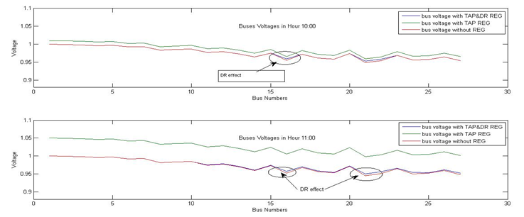

**Figure 8:** Voltage of different buses for three cases from 10 and 11, respectively

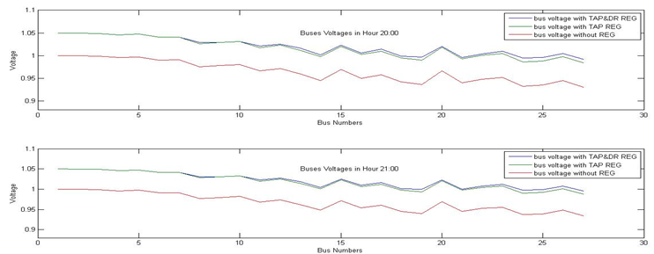

**Figure 9:** Voltage of different buses for three cases from 20 and 21, respectively

**9.Conclusion**

In this article, role of wind turbine in the power system was considered significant if it is disconnected to the network. Voltage profile in network before and after regulation, by considering only tap changer and condition of tap changer and disconnect able loads in different hours were presented. In other words, regulation of voltage which is performed only by response of demand to disconnect able loads as a voltage regulator device is not able to compensate loss of voltage in all buses and in peak hours it must use tap changer. Although in peak hours of consuming, level of tap is placed in the highest amount but still about voltage loss of some buses, there are some problems. Therefore, according to the proposed control method, some buses are selected to decrease their load demands. The proposed method has used measured data at the present time which has been collected by PMU units and determines conditions of tap changer and need to load decrease in order to keep voltage profile .In order to investigate efficiency of the proposed plan, this plan has been tested in an automotive distribution network that simulation results indicate that suitable selection of load decrease can improve voltage profile and in urgent conditions response of demand is an efficient method to keep voltage in an allowed scope.

**References**

[1] Rabiee A, Soroudi A, Mohammadi B, Parniani M. “Corrective voltage control scheme considering demand response and stochastic wind power”. IEEE Transactions on Power Systems, 2014, vol. 29, no.6, pp.2965–2973.

[2] Zakariazadeh A, Homaee O, Jadid SH, Siano P. “A new approach for real time voltage control using demand response in an automated distribution system”.Applied Energy, 2014, vol.117, pp.157-166.

[3] Soroudi A. “Possibilistic-scenario model for DG impact assessment on distribution networks in an uncertain environment”. IEEE Transactions on Power Systems, 2012, vol.27, no.3, pp.1283–1293.

[4] Rabiee A, Soroudi A, “Stochastic multiperiod OPF model of power systems with HVDC-connected intermittent wind power generation”. IEEE Transactions on Power Delivery, 2014, vol.29, no.1, pp.336–344.

[5] Zakariazadeh A, et al. “Stochastic operational scheduling of smart distribution system considering wind generation and demand response programs,”International Journal of Electrical Power & Energy Systems, 2014, vol.63, pp.218-225.

[6] Pereira P, et al. “Optimization of voltage regulators settings and transformer tap zones in distribution systems with great load variation using distribution automation and the smart grids initiatives”. 8th International Conference on the European, Energy Market, May 2011.

[7] Farag HE, El-Saadany EF. “Voltage regulation in distribution feeders with high DG penetration: from traditional to smart”. IEEE Power and Energy Society General Meeting, July 2011.

[8] Elkhatib ME, El-Shatshat R, Salama MA. “Novel coordinated voltage control for smart distribution networks with DG”. IEEE Trans smart grid, 2011, vol.2, pp.598–605.

[9] Jones, D.I., Lorenz, M.H.; ―An Application of a Markov Chain Noise Model to Wind Generator Simulation‖, Math.coput. Simulation, PP.391-402, 1986.

[10] A. Ghafouri, “Fuzzy Controlled STATCOM for Improving the Power System Transient Stability,” 39th North America Power Symposium, 2007, Las Cruces, NM, pp. 212-216, 2007.

[11] Siano P, Cecati C, Yu H, Kolbusz J. “Real time operation of smart grids via FCN networks and optimal power flow”. IEEE Transactions on Industrial Informatics, 2012, vol.8, pp.944–952.

[12] M. Pignati, L. Zanni, P. Romano, R. Cherkaoui, M. Paolone. (2016). Fault Detection and Faulted Line Identification in Active Distribution Networks usin Synchrophasors-based Real-Time State Estimation, IEEE Transactions on Power Delivery, Vol: PP, Issue: 99 Pages: 1 - 1, 2016.