**Hourly Reconfiguration of Large-scale Networks in the Presence of Dispersed generations Based on Changes in Load and Generation Levels with Teaching-Learning Based Optimization Algorithm**

Mojtaba Sokouti bodagh\*a, Aref Jalili iranib

*Department of Power Electrical Engineering Ardabil Branch, Islamic Azad University, Ardabil, Iran*

*\*aEmail: mojtabasokoutibodagh@gmail.com*

*bEmail: arefjalili@gmail.com*

**Abstract**

Reconfiguration of distribution networks is a problem related to exploitation that, due to changes in the mode of switches, causes changes in configuration of distributed feeders to achieve optimal topology in order to minimize network losses. In addition, dispersed generation units play an important role in distribution networks. The present study aims to examine the reconfiguration of distribution networks by considering the effect of changes in generation level of dispersed generation units and also in load levels with Teaching-Learning Based Optimization (TLBO) Algorithm in order to reduce network power losses. Given the fact that presence of dispersed generation units has a significant effect on reducing network losses, it is necessary to extract optimal topologies in the presence of, in the absence of, and based on the changes in the generation level of these units. In this study, analysis of performance is presented on a standard 69-bus distribution network and effectiveness of the proposed method is proven. Also, some part of the real network of Ardabil with two sub-transmission posts and 5 medium-pressure feeders is analyzed as a large-scale network. The simulation results show that reduction of power losses and improvement of the voltage profile in distribution networks are achieved with the presence of dispersed generation units and also reconfiguration of the distribution network.

***Keywords:*** Network reconfiguration, reduction of losses, changes in generation power level and load levels, Teaching-Learning Based Optimization Algorithm

------------------------------------------------------------------------

\* Corresponding author.

E-mail address: mojtabasokoutibodagh@gmail.com

**1. Introduction**

The issue of electric power loss has gained much attention of electrical experts due to the high amounts of damages caused by energy losses in the last decade, and its harmful effects on network, both technically and financially, result in to be analyzed widely and practical ways of its reduction to be determined. Distribution networks are generally radial. To increase the reliability of distribution networks, they are designed with low loops, but they are exploited radially. In a network, usually all branches (lines) can be opened. Obviously, the more switches are in the loop, the more maneuverability is possible. Therefore, there are several paths in the distribution networks to feed each time, one of which can be selected by opening on and closing the switches in the network. Thus, there are various configurations for a distribution network and one can choose a configuration that is technically and economically optimal. Reconfiguration of distribution networks was first introduced by Marilyn in 1975 [9]. In [16], an optimization method is proposed for network configuration based on Plant Growth Simulation Algorithm (PGSA). [17] Suggests that if the loads are not modeled as voltage-dependent and instead are modeled as fixed power, it is possible that the configuration of network result in higher energy consumption and, consequently, higher financial losses. In [18], network reconfiguration has been selected as a single-objective problem in which the main criterion is active power losses, and in order to solve this problem, a Genetic Algorithm is proposed based on the theory of graphs. [19] proposes an Ant Colony Algorithm (ACA) to minimize power losses and to balance load of distribution networks with the presence of scattered power generators. In [22], a method based on Genetic Algorithm (GA) is proposed to investigate the problem of reconfiguration of the distribution system, influenced by changes in the load and power of generation variable of dispersed renewable generation units. In [25], an Evolutionary Algorithm (EA) is shown to solve the problem of radial distribution systems reconfiguration using the Monte Carlo simulation method. In [26], the problem of network reconfiguration is proposed to reduce losses by considering dispersed generation units in the network.

This article includes six sections. In the second section, the TLBO algorithm is expressed to apply to the reconfiguration problem. In the fourth section, the problem formulation is described. In the fifth section, numerical simulation results are provided and finally in the sixth section, conclusions are presented.

**2. TLBO Algorithm**

Training-learning based optimization algorithm was first introduced by Rao in 2011 [35]. The TLBO algorithm is one of the newest evolutionary optimization algorithms designed based on the principles of learning of students and teaching of teachers, and it deals with optimization of various issues using learning and teaching. The population is considered as a class of students. In TLBO, students' scores are similar to propriety in other optimization techniques based on population. The process of TLBO algorithm is simulated in two phases. The first phase or phase of teacher involves learning from teacher, and the second phase or phase of learner means learning through interaction between students. After generating the initial population and evaluating the objective function for each individual separately, phase of teacher and phase of learner are presented as follows [36]:

**2.1.Phase of Teacher**

In this phase, the teacher will try to reach the average score of the class (population) to his/her own level. A good teacher is somebody who brings the level of knowledge of students of a class closer to his/her own level. Therefore, in this phase, followed by a random process, in which for each member or position, a new position is produced as follows:

|  |  |
| --- | --- |
| (1) | $$X_{new,D}=X_{old,D}+r(X_{teacher,D}-T_{F}M_{D})$$ |

where index D denotes the number of old members Xold,D and consists of a 1 × D vector that contains its results for each individual or a particular period. r is a random number in the range of [0,1]. Xteacher,D is the best person of the population in this repetition, TF the teaching factor that can be 1 or 2, MD a vector of 1 × D, which contains the average scores of class for each person or a particular period. The new person Xnew,D is acceptable if he/she is better than the old one.

**2.2.Phase of Student**

Students increase their level of knowledge through two ways of attending the classroom and using the teacher's knowledge and or by reviewing the course with other students. To model this section, it is assumed that each student randomly discusses with another student, and its mathematical model is as follows:

|  |  |
| --- | --- |
| (2) | $$X_{new,i}=X_{old,i}+r_{i}(X_{j}-X_{k})$$ |

where Xold,i is an old student who is compelled to learn knowledge in interaction with other students, ri a random number in the range of [0,1], Xj and Xk two students randomly selected by j and k, where Xj has a value of objective function better than Xk. Xnew,i is selected if he/she is better than the old one Xold,i.

**3. Coding reconfiguration problem**

Each answer to the problem of network reconfiguration is a string of integers, each of which indicates the open switches in the network (figure 1). There are various ways to perform network reconfiguration. In this article, first, all N.O. switches of the network are closed. By doing so, the radial network becomes a circular one. Then, the network switches are open with an innovative algorithm and based on the theory of graphs to create an acceptable radial network.

|  |  |  |  |  |  |  |  |
| --- | --- | --- | --- | --- | --- | --- | --- |
|  | **New student** | |  |  |  |  |  | | --- | --- | --- | --- | --- | | 7 | 10 | 14 | 31 | 37 | |
| |  |  |  |  |  | | --- | --- | --- | --- | --- | | 7 | 11 | 14 | 30 | 36 | |  | |  |  |  |  |  | | --- | --- | --- | --- | --- | | 7 | 9 | 14 | 32 | 37 | |
|  |  | |  |  |  |  |  | | --- | --- | --- | --- | --- | | 7 | 9 | 14 | 28 | 32 | |

**Fig 1:** Selecting a new student in the proposed algorithm

**4 . Problem formulation**

The purpose of the reconfiguration is to reduce active power losses by changing the topological structures of the distribution network by changing the on and off modes of the switches, taking into account the operational and electrical constraints of the network. The objective function that can be considered for minimizing power losses in distribution lines is as follows:

|  |  |
| --- | --- |
| (3) | $$Min P_{Tloss}=\sum_{i=1}^{nb}{\frac{P_{i}^{2}+Q_{i}^{2}}{V_{i}^{2}}}R_{i}$$ |

where PT, Loss is the active power losses of the whole system, nb the total number of branches in the studied network, Pi and Qi the active and reactive powers in the ith branch, Ri the resistance of the ith branch, and Vi the voltage of the ith branch. In order to calculate the power losses of the distribution network as an objective function, in each step of the intelligent optimization algorithm, Forward Backward Sweep (FBS) load flow is used [40].

In addition to minimizing the objective function, electrical constraints of the network should also be observed, which are expressed as follows:

1. Radial structure of network
2. Electro activation of all loads
3. Preservation of the allowed range of the current of branches and voltage of nodes

**4.1. Power losses without reconfiguration and DG**

The power flow in the distribution system is calculated by the return equations obtained from the single-line graph shown in Fig. 2 [23]:

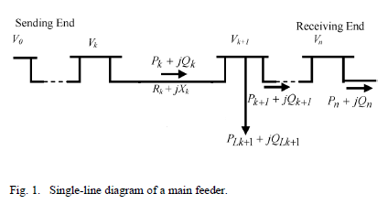

**Fig 2:** Single-line Diagram of a Main Feeder

|  |  |
| --- | --- |
| (4) |  |
| (‏5) |  |
| (6) |  |

where Pk is the active power exited from the bus k, Qk the reactive power exited from the bus k, Rk the ohm resistivity of the branch between the buses k and k + 1, Xk the reactance of the branch between the buses k and k + 1, Vk the voltage of the bus k, PLk + 1 the active load of bus k + 1, QLk + 1 the reactive load of bus k + 1, and Ploss,k is the active loss of the branch k. Power losses of the connection line between k and k + 1 buses are calculated as follows:

|  |  |
| --- | --- |
| (‏7) |  |

The total power losses of feeder PT, Loss, which can be determined from the aggregation of losses from all sections of the feeder line, are as follows:

|  |  |
| --- | --- |
| (8) | $$P_{T,Loss}=\sum_{k=1}^{n}{P_{Loss}\left(k,k+1\right) }$$ |

**4.2. Power losses with network reconfiguration**

The problem of network reconfiguration in a distribution system is to find the best configuration of radial network that reduces power losses, while the voltage profile, the flow capacity of the feeder, and the radial structure of the network are observed. The power losses of a connected line between the buses k and k + 1 after the network reconfiguration can be calculated as follows:

|  |  |
| --- | --- |
| 9)) |  |

Where P\_(k )^'is the active power exited from the bus k after the reconfiguration, Q\_(k )^' the reactive power exited from the bus k after the reconfiguration and V\_(k )^' the voltage of the bus k after the reconfiguration. The total power loss in all feeders, P\_(T, Loss)^', is determined by summing losses from all sections of the network. Therefore, we have:

|  |  |
| --- | --- |
| 10)) | $P_{T,Loss}^{'}=\sum_{k=1}^{n}{P_{Loss}^{'}\left(k,k+1\right)}$ |

Reduced power losses rate ${∆P}_{Loss}^{R}$ in the system is obtained from the difference between power losses before and after the network reconfiguration, which according to equations are as follows:

|  |  |
| --- | --- |
| (11) | $$∆P_{Loss}^{R}=\sum_{k=1}^{n}{P_{T,Loss}\left(k,k+1\right)-\sum_{k=1}^{n}{P_{Loss}^{'}\left(k,k+1\right)}}$$ |

**4.3. Power losses due to installation of dispersed generation units**

When a DG is installed at the desired location on the network, as shown in Fig (3-2), power losses equal:

**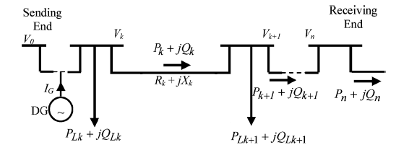**

**Fig 3 :**A single-line diagram of a main feeder with the presence of a DG

|  |  |
| --- | --- |
| (‏(12 | $$P_{DG,Loss}=\frac{R_{k}}{{V_{k}}^{2}}\left({P_{k}}^{2}+{Q_{k}}^{2}\right)+\frac{R_{k}}{{V_{k}}^{2}}\left({P_{G}}^{2}+{Q_{G}}^{2}-2P_{k}P_{G}-2Q_{k}Q_{G}\right)$$ |

where PG is the active power generated by DG, and QG the reactive power generated by DG.

Reduced power losses rate ${∆P}_{Loss}^{DG}$ in the system is obtained from the difference between power losses before and after the installation of DG units:

|  |  |
| --- | --- |
| (13) | $$∆P_{Loss}^{DG}=\frac{R_{k}}{{V_{k}}^{2}}\left({P_{G}}^{2}+{Q_{G}}^{2}-2P_{k}P_{G}-2Q_{k}Q_{G}\right)$$ |

The positive sign of ${∆P}_{Loss}^{DG}$ indicates that system losses are reduced with DG installation and commissioning. Conversely, the negative sign of ${∆P}_{Loss}^{DG}$ indicates that the DG installation causes an increase in system losses.

**5. Numerical simulation**

To demonstrate the effectiveness of the proposed method (simulation of network reconfiguration and installation of dispersed generation units) using a teaching-learning based optimization algorithm, this method is applied on two 69-bus networks and one large-scale real network (five 20 kV feeders with two sub-transmission posts).

**5.1. Initial state of the network: without reconfiguration and without installing dispersed generations**

The switches 69-70-71-72-73 are on in the initial state. Performing the calculations of load flow, network losses in initial state and before performing reconfiguration and changing the status of the switches equal 225 kilowatts. The lowest voltage range in bus 65 occurs with the range of 0.9092 per unit.

**5.2. Examination of two possible new configurations**

Power losses of the network after performing reconfiguration with switches 55-24-44-36-16 at an open state equal about 139 kilowatts, which is 38% lower compared to the initial state where the network losses were about 225kW. Fig. (4) shows the voltage values of each single bus before and after the reconfiguration. The power losses of the network after reconfiguration with the switches 69-70-57-61-14 in the open state obtained about 98.5 kilowatts, which has reduced 56 percent compared with the initial state that the network losses were about 225 kilowatts. Fig. (5) shows the values of the voltage of each single bus before and after the reconfiguration.

**Table 1:** Comparison of power losses and voltage range of several possible configurations

|  |  |  |
| --- | --- | --- |
| The lowest voltage range (pu.) | power losses (kw) | configuration |
| 0.9092 | 225 | 69-70-71-72-73 |
| 0.9322 | 139 | 55-24-44-36-16 |
| 0.9501 | 98.5 | 69-70-57-61-14 |

3.emf

**Fig 4** :Voltage values of each single bus before and after reconfiguration in a 69-bus network (55-24-44-36-16)  
5.emf

**Fig5** :Voltage values of each single bus before and after reconfiguration in a 69-bus network (69-70-57-61-14)

**5.3. Installing three DG units in the 69-bus network**

In this section, three wind, solar and small water units are installed in buses 61, 42 and 21 with nominal capacities of 800, 500 and 1000 kilowatts, respectively, and the switches 69-70-71-72- 73 are the same as the initial switches of the network at the open state. It is assumed that dispersed generation units are only capable of acquiring active power and are modeled as active power supply sources. The network power losses after installing dispersed generation units were obtained 115.5 kilowatts, which have reduced 48.5 percent compared with the initial state which power loss was about 225 kilowatts. Fig. (6) shows the voltage values of each single bus before and after the reconfiguration. It can be seen that the installation of dispersed generation units, as well as the network reconfiguration, greatly reduces network power losses. According to Fig. (6), the lowest voltage range is improved from 0.9092 per unit in bus 65 to 0.9465 in bus 65.

6.emf

**Fig 6:** Voltage values of each single bus before and after DG's installation with unit power coefficient in the 69-bus network

**5.4.Hourly optimization of the 69-bus network**

To hourly analyze the position of the 69-bus network, loads of the network are modeled as three domestic, industrial and commercial load patterns [40]. Fig. (7) shows the domestic, industrial and commercial load patterns as a percentage of peak load (per unitized) in a day and a night.

**Table 2:** Scattering of different types of domestic, commercial and industrial loads in the studied network

|  |  |  |
| --- | --- | --- |
| Buses with domestic load pattern | Buses with commercial load pattern | Buses with industrial load pattern |
| 2-3-4-6-11-12-13-15-18-21-22-25-30-33-35-36-37-39-44-45-46-48-51-54-55-58-63-64-66-69 | 5-10-14-19-20-24-27-29-32-34-38-43-47-52-53-57-60-62-65 | 7-8-9-16-17-23-26-28-40-41-42-49-50-56-59-61-67-68 |

RIC.emf

**Fig. 7** Domestic, industrial and commercial load patterns

pv_wt_shp.emf

**Fig 8:** The amount of hourly generation power of wind, solar and small water resources [39]

Also, three types of dispersed generation sources provided by wind, solar, and water sources are included in this survey. Fig. (8) shows the amount of hourly generation power per-unitized to the maximum generation power of the generation units affected by wind speed, solar radiation, and also water flow [39].

Considering load data related to the pattern of domestic, industrial and commercial load, the total network load at different hours in a day and a night by summing different loads in different buses is shown in Fig. (9). The largest load range for this network was at 7 p.m. and included 3495 kilowatts.

1.emf

**Figure 9:** The total hourly load of the 69-bus network

Fig. (10) shows the voltage values of each single bus in a day and a night in the initial state of the 69-bus network. According to the figure, the lowest voltage range in buses and at different hours changes between 0.95 per unit to about 1.03 per unit.

v_before.emf

**Fig 10:** The values of the voltage of each single bus in a day and a night before the hourly optimal reconfiguration

Fig. (11) shows network power losses at different hours before and after optimal reconfiguration. The values of the voltage of each single bus in a day and a night after the hourly optimal reconfiguration of the 69-bus network are shown in Fig. (12). Comparing the Figs. (10) and (12), which show the voltage values of each single bus of the 69-bus network before and after the optimal reconfiguration, indicates that the voltage profile is improved in a day and a night (24 hours) after performing the reconfiguration.

loss_24.emf

**Fig 11:** Comparison of power losses of the 69-bus network at different hours before and after hourly optimal reconfiguration

v_after.emf

**Fig 12** :Voltage values of each single bus in a day and a night after the hourly optimal reconfiguration of the 69-bus network

**5.5. Study of the real network of Ardabil**

According to Fig. (13), this area is loaded through 5 feeders (western one: pink, western three: green, western six: turquoise, southern seven: purple, and southern eight: red), which is fed through two sub-transmission posts (western and southern). The total number of posts equals 149 posts with a total capacity of 40260 KVA.  
Network information is extracted from GIS and implemented by the modeling performed as a 966-bus network in MATLAB software environment. The initial topology of the studied network extracted from the GIS environment is shown in Fig. (13). Thirteen points marked on the figure, switches and connections are open in normal mode, so there are thirteen loops in the network. The locations of the two sub-transmission posts are also shown in the figure.

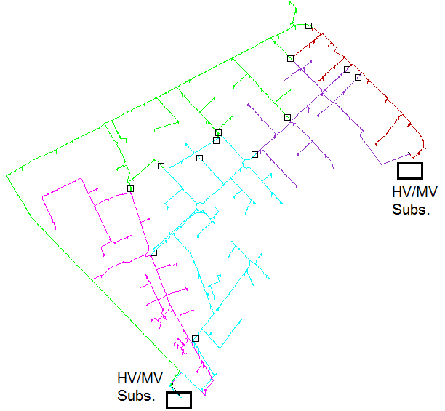

**Fig 13:** Initial topology of the studied network extracted from the GIS environment

**5.1.1. The initial state of real network of Ardabil with peak load**

By applying the load flow on the modeled 966-bus distribution real network of Ardabil, the lowest network voltage is related to the bus 393 with a value of 0.95464 per unit and an active power loss of 569.71 KW is achieved. The voltage profile in the initial state of Ardabil's real network is presented in Fig. (14). The transmission power in the lines of the studied network is shown in Fig. (15).

volt_ini 966.emf  
**Fig 14:** Voltage profile in the initial state of the real network of Ardabil

1.emf

**Fig 15:** The transmission power of the lines of the studied network in the initial state

The transmission power of feeders under study in the initial state is shown in Table (3). In the initial state of loading, the sub-transmission post of the West is 24,138 kilowatts and the southern sub-transmission post is 8,606 kilowatts.

**Table 3:** Transmission power of the feeders under study in the initial state

|  |  |  |  |  |  |
| --- | --- | --- | --- | --- | --- |
|  | Western One | Western Three | Western Six | Southern Seven | Western Eight |
| Number of section | 1 | 201 | 399 | 752 | 817 |
| Transmission power (KW) | 7423 | 8646 | 8069 | 3195 | 5411 |

Location of the bus in which the smallest voltage range occurs is indicated by the star sign in Fig. (16). This point is the end point of the western 3 feeder and also has a relatively heavy load compared to other feeders.

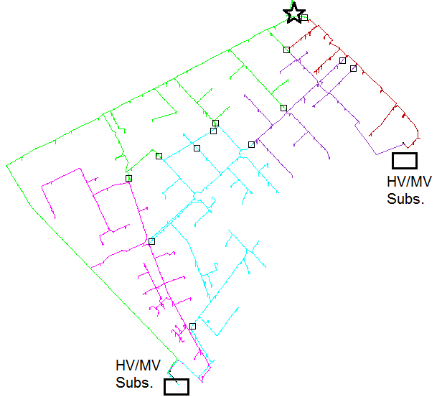

**Fig** 16**:** Location of the bus with the lowest voltage range in the initial topology (bus 393 with the amount of 0.95464 per unit)

If the two 200kW solar power plants installed on bus No. 310 of the western 6 feeder and the 660kW wind turbine installed on the bus No. 185 of the western 3 feeder are included in the calculations, then the following results will be obtained. The positions of the solar and wind units on the network are shown in Fig. (17).

Assuming the unit power coefficient for solar and wind units, power losses of network will be 528 kilowatts after considering dispersed generation units, and the lowest voltage range of the network will be 0.95732 per unit in bus 363. The lowest voltage range in bus 363 occurs at one of the end points of western 3 feeder, as shown in Fig. (17).

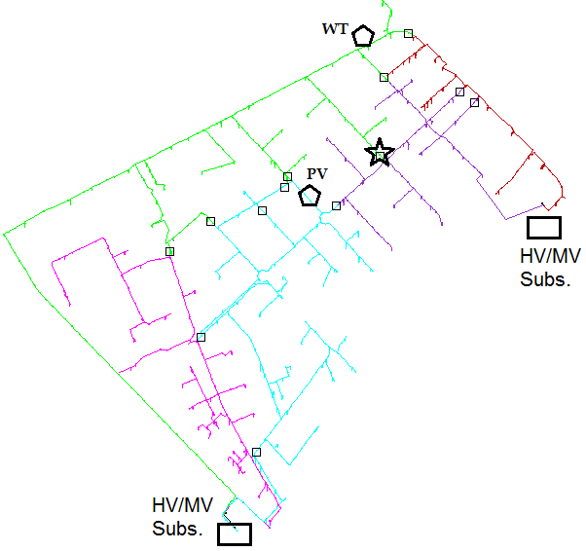  
**Fig 17:** Occurrence location of the lowest voltage range with the presence of DGs (bus 393 at the end of western 3 feeder)

**5.1.2. TLBO of the real network of Ardabil with peak Load**

Comparison of the results of power losses and voltage profiles before and after the reconfiguration of the real 966-bus network of Ardabil using the TLBO algorithm shows that the worst voltage range improves from 0.95464 in bus 393 to 0.97517 per unit in bus 730, and the active power losses improve from 569.71 to 397.18 KW (equal to 30% improvement). The voltage profiles of the network before and after the reconfiguration are presented in Fig.(18).Fig. (19) shows the topology of the 966-bus network of Ardabil’s real network after optimal reconfiguration. In this figure, the location of switches (13 switches shown with the square sign) is displayed in normal mode. Also, the location of the bus in which the lowest voltage range occurs is indicated by the star sign. This point is the end point of the western 6 feeder

1.emf

**Fig 18** :Voltage profiles before and after reconfiguration of the 966-bus network with the TLBO algorithm

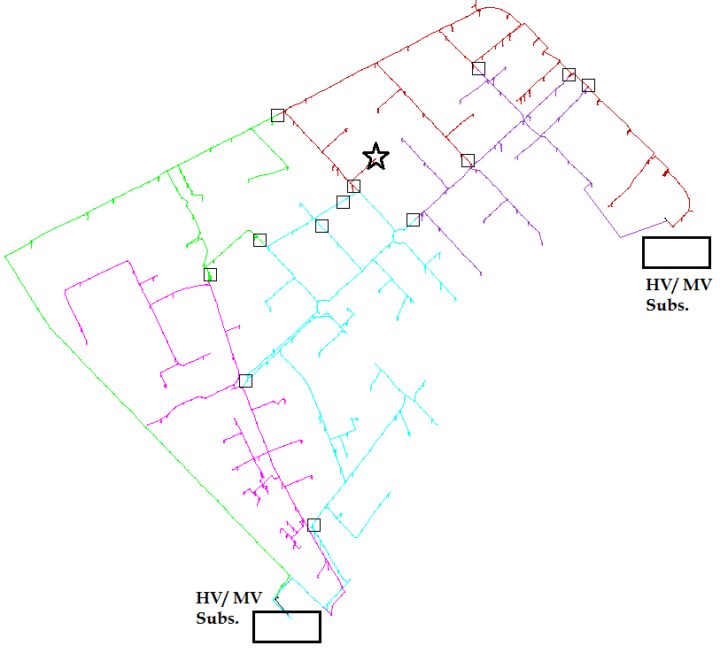

**Fig 19** :Location of the bus with the lowest voltage range (bus 730 with the amount of 0.97517 per unit)

The comparison between the initial topology and the optimal topology obtained for the real network of Ardabil shows that only by changing the mode of a switch pair, 30% reduction occurs in power losses. Also, the lowest voltage range is also improved compared to the initial state of the network.

The optimization process of TLBO algorithm is shown in fig. (20) for 100 consecutive repetitions.

1.emf

**Fig 20:** Optimization process of reconfiguration problem of the 966-bus real network of Ardabil with TLBO algorithm

The transmission power of the feeders under study in the initial state is shown in Table (4). Loading of the western sub-transmission post in the initial state has dropped from 24,138 kW to 20,786 kW after loading, and the southern sub-transmission post has increased from 8606 to 11786 kW after loading. As the results show, load of the feeder No. 3 of the western sub-transmission post has dropped to 3,352 kW, and the load of the feeder No. 7 of the southern sub-transmission post has increased by 3,180 kW, which in addition to posts’ load balancing, has also reduced power losses. The transmission of the load between the feeders of the sub-transmission post of the West is also evident.

Translation errorTable 4 Transmission power through the feeders of the 966-bus real network of Ardabil after optimization

|  |  |  |  |  |  |
| --- | --- | --- | --- | --- | --- |
|  | Western one | Western three | Western six | Southern seven | Southern eight |
| Transmission power (KW) before reconfiguration | 7423 | 8646 | 8069 | 3195 | 5411 |
| Transmission power(KW) after reconfiguration | 7423 | 5294 | 8069 | 6375 | 5411 |

Translation errorThe transmission power of the lines of the studied network is also shown in Fig. (21).  
1.emf  
**Fig 21:** The loading rate of the lines after performing the reconfiguration with the TLBO algorithm

Comparing Figs. (15) and (21), which show the loading volume of the lines before and after the optimal reconfiguration respectively, indicates that the transmission power of some lines has decreased and in some other lines, the power transmission has increased. This indicates the transmission of power from some lines to other lines to reduce power losses.

**6.Conclusion**

Dispersed generation sources are becoming popular because of the increased demand for electrical energy in distribution networks. In this research, the reconfiguration of distribution networks is examined by considering the effect of changes in the level of generation of dispersed generation units and load levels with the teaching-learning based optimization (TLBO) algorithm to reduce network power losses. Given the fact that the presence of dispersed generation units has a significant effect on reducing network losses, it is necessary to extract optimal topologies in the presence of, in the absence of, and based on the changes in the level of generation of these units. The performance analysis is presented on a standard 69-bus distribution network and the effectiveness of the proposed method is proven. Also, part of the real network of Ardabil with two sub-transmission posts and 5 medium-pressure feeders is analyzed as a large-scale network.

**Reference**

[1] M. A. Kashem, “A Novel Method for Loss Reduction in Networks,” IEEE Trans. on Power Del., Apr. 2000.

[2] T. Ackermann, G. Andersson, L. Soder, “Distributed generation: a definition,” Electric Power Systems Research 57 (2001) 195–204

[3] CIGRE, “Impact of increasing contribution of dispersed generation on the power system,” working group 37.23, 1999.

[4] S. Kotamarty, S. Khushalani, N. Schulz, “Impact of distributed generation on distribution contingency analysis,” Electric Power Systems Research 78 (2008) 1537–1545

[5] Borges CLT, Falcao DM. “Impact of distributed generation allocation and sizing on reliability, losses and voltage profile,” In: Proceedings of IEEE Bolonga power technology conference, 2003.

[6] C. H-Zhong, C. J-Fu, D. Xianzhong, “Study on Powe Flow Calulation of Distribution System with DGs,” Journal of Automation of electric power system, 2006, 30(1): 35-40.

[7] W. Krueasuk, W. Ongsakul, “Optimal Placement of Distributed Generation Using Particle Swarm Optimization” Asian Institute of Technology- Energy Field of Study- 2006

[8] Rao RV, Savsani VJ, Vakharia DP. “Teaching-learning-based optimization: a novel method for constrained mechanical design optimization problems,” Computer Aided Design 2011; 43:303–15

[9] Rao, R. V., V. J. Savsani, and D. P. Vakharia. “Teaching–learning-based optimization: an optimization method for continuous non-linear large scale problems.” Information Sciences 183.1 (2012): 1-15.

[10] P. Chiradeja, and R. Ramakumar, "An Approach to Quantify the Technical Benefits of Distributed Generation," IEEE Transactions on Energy Conversion, Vol. 19, No. 4, dec. 2004, pp. 764-773

[11] T. Ackermann, G. Andersson and L. SÖder, "Distributed Generation: A definition," Electric Power Systems Research 57, pp195-204, 2001.

[12] C. Wang and M. H. Nehrir, "Analytical Approaches for Optimal Placement of Distributed Generation Sources in Power Systems," IEEE Transactions on Power Systems, Vol.19, no.4, pp. 2068-2076, 2004.

[13] C. Wang, H.Z. Cheng, "Optimization of Network Configuration in Large Distribution Systems Using Plant Growth Simulation Algorithm," IEEE Transactions on Power System, Vol. 23, No. 1, pp.119-126, Feb. 2008.

[14] D. Singh, R. K. Misra,"Load type impact on distribution system reconfiguration," Elec. Power and Energy Syst. Vol. 42, No. 5, pp. 583–592, June 2012.

[15] B. Tomoiag, M. Chindris, A. Sumper,R. Villafafila-Robles, A. Sudria-Andreu, "Distribution system reconfiguration using genetic algorithm based onconnected graphs," Electric Power System Research Vol. 104, pp. 216–225, June 2013.

[16] Y.K. Wu, C. Lee, L.C. Liu, S.H. Tsai, "Study of Reconfiguration for the Distribution System With Distributed Generators," IEEE Transactions on Power delivery, Vol. 25, No. 3, pp. 1678-1685, July 2010.

[17] J. S. Savier, D. Das, "Impact of Network Reconfiguration on Loss Allocation of Radial Distribution Systems," IEEE Transactions on Power delivery, Vol. 22, No. 4, pp. 2473-2480, Oct. 2007.

[18] C. F. Chang, "Reconfiguration and Capacitor Placement for Loss Reduction of Distribution Systems by Ant Colony Search Algorithm," IEEE Transactions on Power Systems, Vol. 23, No. 4, pp. 1747-1755, Nov. 2008.

[19] A. Zidan, E.F.Saadany, "Distribution system reconfiguration for energy loss reduction considering the variability of load and local renewable generation," Energy, Vol. 59, pp. 698-707, July 2013.

[20] R.S. Rao, K. Ravindra, K. Satish, S.V.L. Narasimham, "Power Loss Minimization in Distribution System Using Network Reconfiguration in the Presence of Distributed Generation," IEEE Trans. on Power Syst., Vol. 28, No. 1, pp 317-325, Feb. 2013.

[21] J. Olamaei, T. Niknam, G. Gharehpetian, "Application of particle swarm optimization for distribution feeder reconfiguration considering distributed generators," Applied Mathematics and Computation 201, pp. 575–586, 2008.

[22] J .C. Cebrian, N. Kagan, "Reconfiguration of distribution networks to minimize loss and disruption costs using genetic algorithms," Electric Power System Research, Vol. 80, pp. 53–62, 2010.

[23] A. Y. Abdelaziz, R. A. Osama, S.M. Elkhodary, E.F.El-Saadany, "Reconfiguration of Distribution Systems with Distributed Generators using Ant Colony Optimization and Harmony Search Algorithms," IEEE, 978-1-4673-2729-9/12, 2012.

[24] S. G. Naik , D. K. Khatod, M. P. Sharma, "Optimal allocation of combined DG and Capacitor for real power loss minimization in distribution networks," Electric Power and Energy System, Vol. 53, pp 967–973, June 2013.

[25] H. Moarrefi, M. Nematollahi, M. Tadayon, "Reconfiguration and Distributed Generation (DG) Placement Considering Critical System Condition," 22nd International Conference on Elec. Distribution, No. 0732, June 2013.

[26] W. M. Dahalan, H. Mokhlis, "Network Reconfiguration for Loss Reduction with Distributed Generations Using PSO," IEEE International Conference on Power and Energy, Kota Kinabalu Sabah, Malaysia, Dec. 2012

[27] H. Zhang, Sh. Ma, G. Xu, "Network Reconfiguration of Distribution System with Distributed Generation Using State Graph," IEEE, No.577-0547-2/12, 2012

[28] Aboelsood Zidan, Ehab F. El-Saadany, "Distribution system reconfiguration for energy loss reduction considering the variability of load and local renewable generation," Energy 59 (2013) 698-707

[29] Lothar M. Schmitt, "Fundamental Study Theory of genetic algorithms," Theoretical Computer Science 259 (2001) 1–61

[30] Storn, R. Price, K. "Differential evolution - a simple and efficient heuristic for global optimization over continuous spaces," Journal of Global Optimization Vol. 11, 1997; pp. 341–359.

[31] M. Varadarajan and K.S. Swarup, "Differential evolutionary algorithm for optimal reactive power dispatch," Electrical Power and Energy Systems 30 (2008) 435–441

[32] Jen-Hao Teng, "A Direct Approach for Distribution System Load Flow Solutions", IEEE Transactions on Power delivery, Vol. 18, No. 3, July 2003

[33] T. Niknam, "An efficient hybrid evolutionary algorithm based on PSO and ACO for distribution feeder reconfiguration," Europian Transactions on Electric Power (2009)

[34] T. Niknam, "An efficient multi-objective HBMO Algorithm for Distribution Feeder Reconfiguration," Expert Systems with Applications 38 (2011) 2878-2887

[35] R. Srinivasa Rao, S. V. L. Narasimham, M. R. Raju, and A. Srinivasa Rao, "Optimal Network Reconfiguration of Large-Scale Distribution System Using Harmony Search Algorithm," IEEE Trans. on Power Syst., Vol. 26, No. 3, Aug. 2011

[36] Bayat, "Uniform Voltage Distribution Based Constructive Algorithm for Optimal Reconfiguration of Electric Distribution Networks," Electric Power Systems Research 104 (2013) 146-155

[37] Shirmohammadi D, Hong HW. "Reconfiguration of Electric Distribution Networks for Resistive Line Loss Reduction," IEEE Transactions on Power Systems 1989; 4(1): 1492-1498

[38] A. Mohamed Imran, M. Kowsalya a, D.P. Kothari, "A novel integration technique for optimal network reconfiguration and distributed generation placement in power distribution networks," Electrical Power and Energy Systems 63 (2014) 461–472

[39] D.P. Bernardon, A.P.C. Mello, L.L. Pfitscher, L.N. Canha, A.R. Abaide, A.A.B. Ferreira, "Real-time reconfiguration of distribution network with distributed generation," Electric Power Systems Research 107 (2014) 59– 67