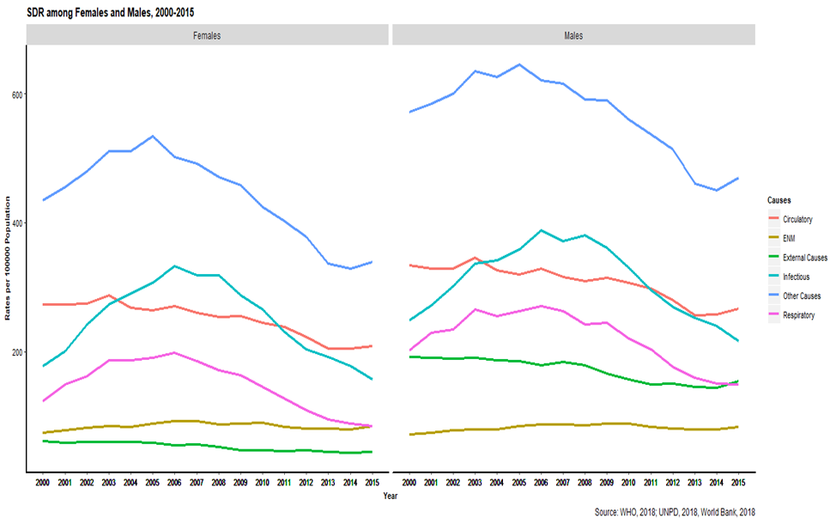
Figure 1: Age-standardised death rates (SDR) from infectious circulatory, respiratory, endocrine, nutritional and metabolic diseases, external causes and other causes of death in males and females (South Africa, 2000-2015)

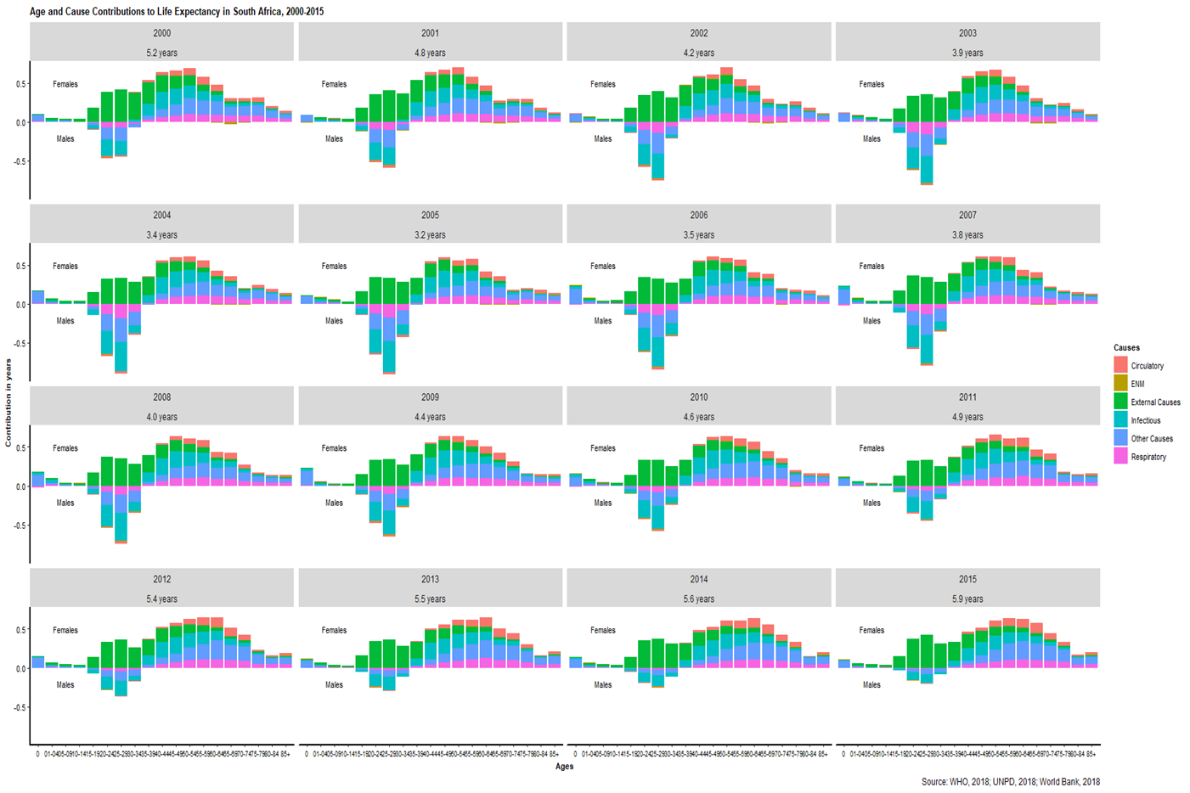
Figure 2: Decomposition of the contribution of major classes of causes of death to life expectancy by (South Africa, 2000-2015).
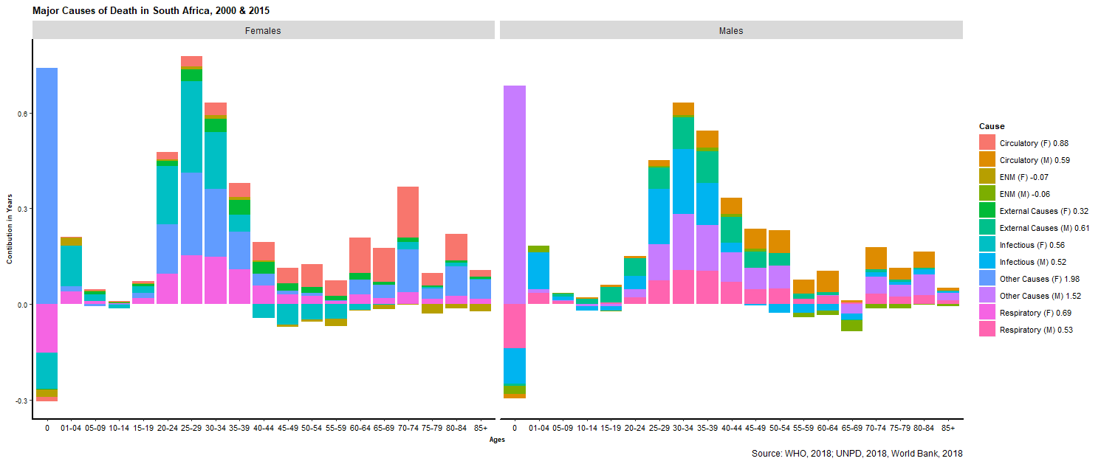
Figure 3: Decomposition of the contribution of the major classes of causes of death to life expectancy for males (M) and females (F) (South Africa, 2000-2015)

